Table of Contents

Notice of the 52ND National Annual General Meeting 4
Message from National Executive Committee Chairperson 5
Message from National General Secretary 5

About Kenya YMCA 6 - 7

Thank you to our partners 8

Highlights from the Year 8

Empowering young people for the African Renaissance 9

Programmes 9
- Civic competence 10
- Economic empowerment 11 - 12

Services 12
- Early Childhood Development Centres and Primary School Education 12 - 13
- Vocational Training Centres 13 - 14
- Health 14
- Sports and Recreation 15

Advocacy 16

Refurbishing the 'home away from home' 17 - 18

Strengthening Kenya YMCA 19

Financial reports 20
- Statement of the National Executive Committee's Responsibilities
For the year ended 31 December, 2013 20
- Treasurer's report on financial performance 21 - 23
- Consolidated statement of comprehensive income for 2013 24
- Consolidated statement of financial position as of 31st December, 2013 25
- Report of the Independent Auditors to the members of Kenya YMCA 26 - 27

National leaders of Kenya YMCA 28

Directory of Kenya YMCA groups, branches and units 29 - 30

Notice of the 52nd National Annual General Meeting

Notice is hereby given that the 52nd Annual General Meeting of the Kenya Young Men's Christian
Association will be held at the YMCA conference Hall, State House Road, Nairobi on Friday 6th June,
2014 from 8.30am.

Formal business

1. To receive the report of the National Executive Committee on the activities of the Kenya
YMCA and its members;
2. To receive, discuss and pass the 2013 annual financial report of Kenya YMCA;
3. To elect members and officers of the National Executive Committee to replace those due for retirement at the end of the year 2013 in accordance with the YMCA election by-laws;
4. To appoint independent auditor for the year 2014;
5. To discuss any other business notified to the National Chairman in writing.

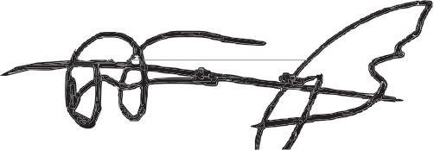

Jared Musima
National General Secretary
For: National Executive Committee

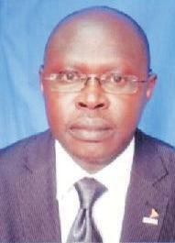Message from Mr Patrick Kaptway
National Executive Committee Chairperson

On the 4th March 2013 Kenyans went to the ballot box and voted in the first election under the new Constitution of Kenya 2010. The result ushered in a devolved system of government; a new distribution of power which offers great opportunity for our young people to influence the future of their country.

Now, more than ever, Kenya YMCA needs to strive to support our young members in moving from a state of subject to a state of active citizenship. We need to enable them to identify and articulate the issues that matter to them
and help them get their voice heard. Now, more than ever, Kenya YMCA must recommit to its vision of empowering the young people of Kenya for the African Renaissance.

It is my pleasure to acknowledge that this need for action has not been ignored. 2013 saw a 40% increase in members from 2012 levels. This is a tremendous success that could not have been achieved without the dedication and hard work some of our branch staff, youth members and volunteer-run committees. This report details the activities of those members and their branches across programmes, services and advocacy efforts. I look forward to the next year as we seek to replicate these successes across the counties in 2014, drive membership levels up further and enable our young people to set this country on the development path they deserve.

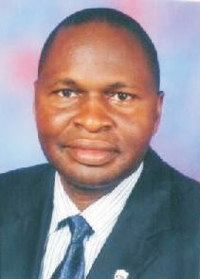Message from Mr Jared Musima
National General Secretary

Kenya YMCA is now half way through the implementation of its Strategic Plan
2012 – 2016. It was timely therefore that a Peer Review process was undertaken this year with highly-valued facilitation by the African Alliance of YMCA. This engaged period of reflection allowed us, as an organisation, to celebrate the progress we have made including contributing to the development of the National Youth Policy from 2001- 2005 and piloting the adoption of the Subject 2 Citizen philosophy that now unites YMCAs in
20 African countries through our overarching vision of youth empowerment.

The review also provided an opportunity to take stock of those areas we need to work harder on if we are going to be able to fulfil our mission of developing the spiritual, mental and physical well-being of young people. Peer Review meeting recommendations included among others: development of a stronger gender policy, the formation of a membership recruitment committees and a broader embrace of the Subject to Citizen Philosophy across the country by more branches.

We look forward to 2014 as the time to start evaluating progress on those recommendations and leveraging on our achievements using the Subject to Citizen philosophy; a philosophy that has the potential to truly bring the branches to life through the championing of youth-led projects, programmes and initiatives.

About Kenya YMCA

78% of Kenyans are under the age of 34 years. They are the future of Kenya. Kenya YMCA's vision is to empower these young people for the African Renaissance.

Kenya YMCA strives to achieve this vision by taking a holistic approach to developing the physical, mental and spiritual well-being of youth to
Enable them to become responsible citizens.
This unique approach is known as the YMCA Triangle.

Since its establishment as a voluntary, Christian membership movement over 100 years ago in 1910, Kenya YMCA has served well over 13 million people throughout the nation.

Body
The YMCA Triangle

Soul

Mind

How we work

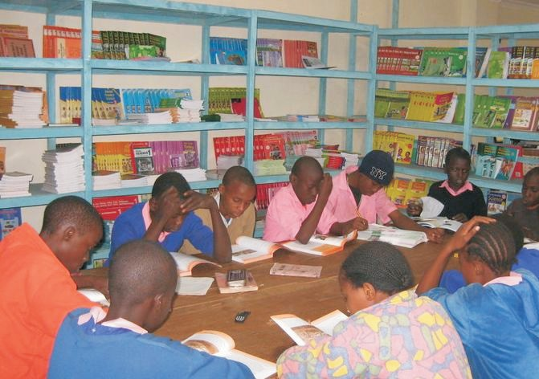As a nonprofit making organisation, we deliver our mission and commitment to improve the quality of life for youth, vulnerable women and children, Kenya YMCA works at both the individual level by creating empowerment and development opportunities for young people, and at the community level through advocacy, civic competence, skills development, reproductive health and the provision of key services such as education, training and sports and wellness facilities.

Each branch aims to function as a “home away from home”; places where needs can be met and potential nurtured. As a membership organization, committed to the value of volunteerism, we provide unique opportunities for young people to participate in leadership and self-determination, truly ensuring that the YMCA meets the needs of the youth and the community at large.

Core values

Kenya YMCA is a non-denominational Christian organization which believes in God the Father, God the Son and God the Holy Spirit – The Holy Trinity - and in furtherance of His Kingdom to all in accordance with the Holy Bible.

Further, it believes in:

- Preventative and proactive approach to delivery of its mandate
- Accessibility, affordability and commitment to quality
- Creativity and social innovation
- Volunteerism and professionalism
- Equity, diversity and inclusion
- Integrity

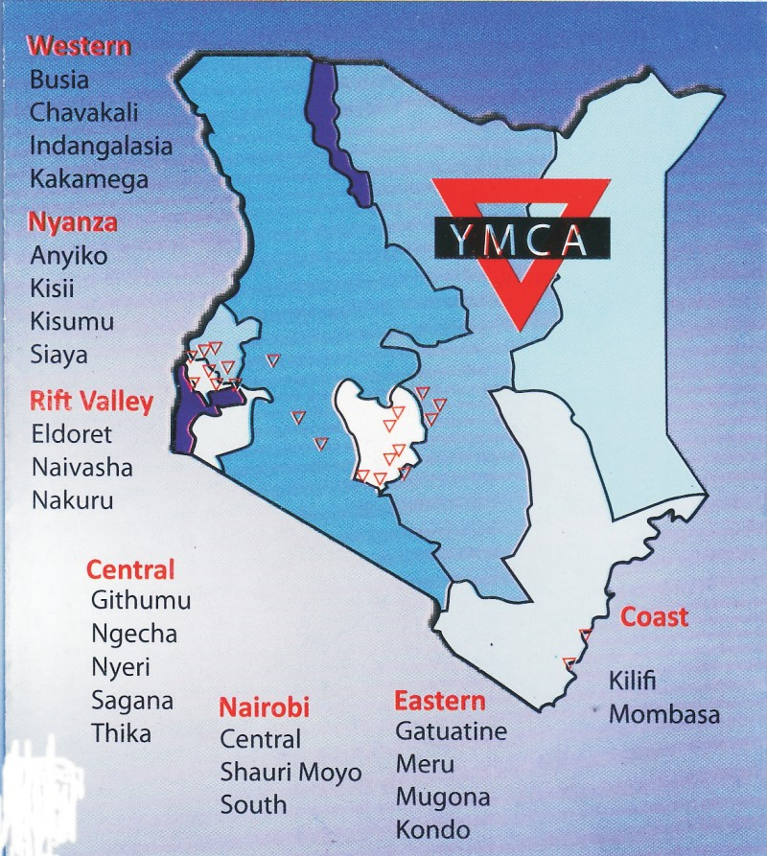Where we work

Kenya YMCA serves the young people of Kenya through a network of 24 branches and units in 16 Kenyan counties giving it
a national outlook.

The Association has strong connections across the world through affiliation to the international network of YMCAs.

Thanks to our partners

The work of Kenya YMCA would not be possible without our partners. In 2013 we would like to thank:

Africa Alliance of YMCA Baden YMCA
Beth Magomolla
Catholic Peace and Justice Commission
Chemonics International Cockroach Exchange Junior Achievement
Kenya Prisons Department
Kenya Private Sector Alliance (K EPSA) Kilifi Constituency Aids Control Council Ministry of Youth Affairs

National Authority for the Campaign Against Alcohol and Drugs Abuse (NACADA)
National Aids Control Council
NGO Council Safaricom Foundation Scriptures Union
Voluntary Service Overseas (V SO) Work Aid International
World Vision
Ottawa Y’s Men Club
Y’s Men International

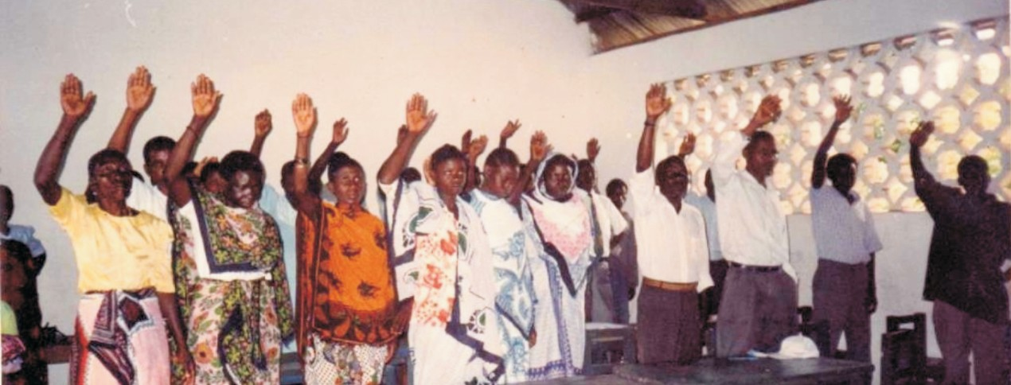Highlights from 2013

Membership recruitment and strategy developed to be used to enhance membership recruitment and retention.

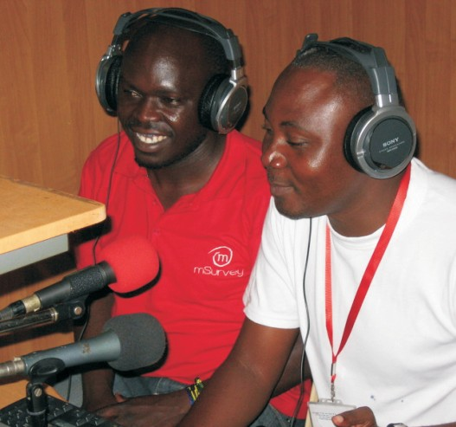• 1,204 pupils received primary school education

• 629 students in 7 Vocational Training Institutes country-wide

• 2,500,000 million radio listeners reached by youth advocacy trained media professionals

• 50 agribusiness farms supported by a water irrigation project in Kondo

Empowering Young People for the African Renaissance

Kenya YMCA strives to achieve its vision of empowering young people for the African renaissance through youth empowerment and development programmes, services and advocacy. The highlights below summarises key achievements during the year 2013.

Programmes in 2013

Kenya YMCA strongly believes that youth in the whole country can be transformed into active citizens. Each branch runs a wide range of youth empowerment and development programmes designed to enable the young people fulfil their potential. To focus our efforts on the most critical challenges, Kenya YMCA provides the required space for youth to exploit their God given talents to the fullest. It was in this spirit that the Subject to Citizen (S2C) philosophy was adopted in 2009, a philosophy that has gone a long way to unite YMCAs across the African continent.

A brief introduction to S2C

The Subject to Citizen (S2C) philosophy was carefully crafted to equip youth with the skills and confidence to transform themselves and other young people through influence that is engrained with positive values in life. It is based on the concept that young people are subjects in the way they are both excluded and manipulated politically, economically and socially. The result is that many youth are at risk, idle, lack hope and confidence and are thus open to exploitation and taking up violence. S2C moves youth from a state of subjects to a state of citizenship where they understand the root causes of their challenge in life, articulate viewpoints and become part of positive change at various levels of decision-making.

f r o m s u b j e c t

S2C focuses on four pillars of youth transformation:

1. Civic Competence
2. Economic Renaissance
3. Transformative Masculinity
4. Youth Justice

In 2013, Kenya YMCA prioritised action in two areas: civic competence and economic renaissance.

Civic Competence Programmes

The Kenyan Government is opening up many opportunities for young people to participate in decision- making and tackle the challenges facing them. Civic competence programmes are aimed at increasing the awareness and confidence of young people so that they can spot – and take advantage of – the opportunities for practical action and advocacy in their communities. In this way they can lead the change they want to see rather than waiting for others to act for them.

To date, Kenya YMCA has trained well over 30,000 young people to be S2C Change Catalysts and reached over 2,500,000 people through S2C interventions. Below are a few examples of the activities undertaken in
2013 as part of the initiative.

Mombasa YMCA delivered a four-day training course on the theme “empowering journalists in reporting on women, youths and children” to eight media houses: Sheki FM, Radio Salaam, Radio Rahma, Pwani FM, Baraka FM, Radio Kaya, Bahari FM and Pilipili FM.

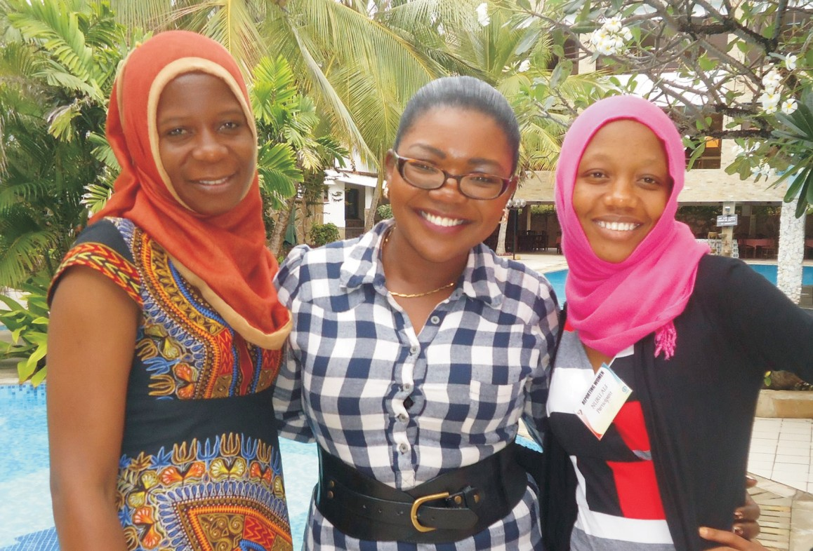The training, held in partnership with Plan International, Sheki FM Radio and the Media Council of Kenya, was devoted to empowering and strengthening the engagement and participation of journalists in sustainable development. Special focus was drawn to child pregnancies, female genital mutilation, early marriages and cultures and traditions that undermine women. The result is radio show called HOPE (TUMAINI) which to date has reached 2.5 million people in Kilifi and Kwale.

From left: Amina Chombo, senior reporter Radio Kaya; Irene Ayimba, training facilitator;
Nuru Ali producer Sheki Radio.

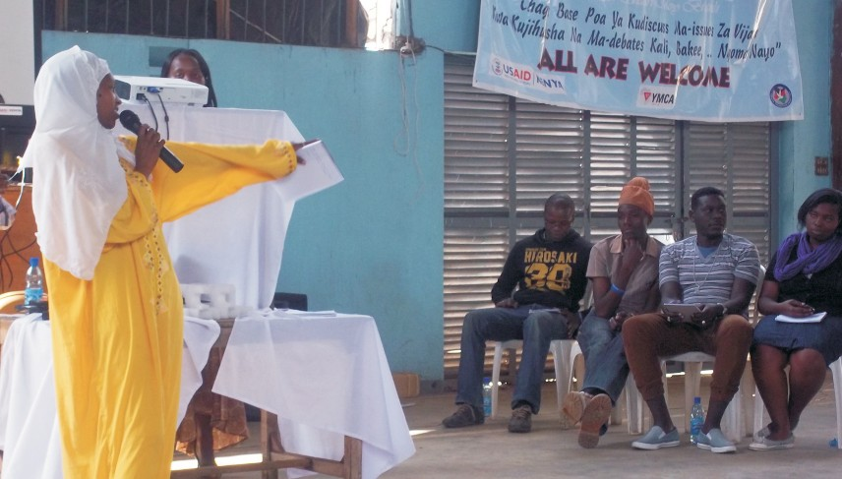Shauri Moyo YMCA tackled a different issue of particular relevance in their community neighbouring Eastleigh in Nairobi – that of violent extremism. The project, funded by Chemonics International, engaged over 3,000 people and had two main objectives. Firstly, to engage youth in constructive activities during their free time and provide an alternative to the influence of criminal and extremist elements in the community. Secondly, to create safe space for youth to discuss sensitive topics. To achieve this, a series of youth debates including video screenings and conversations on radicalisation and extremism were combined with sporting events such as inter-community basketball games.

Economic renaissance
Youth member addressing peers on extremism

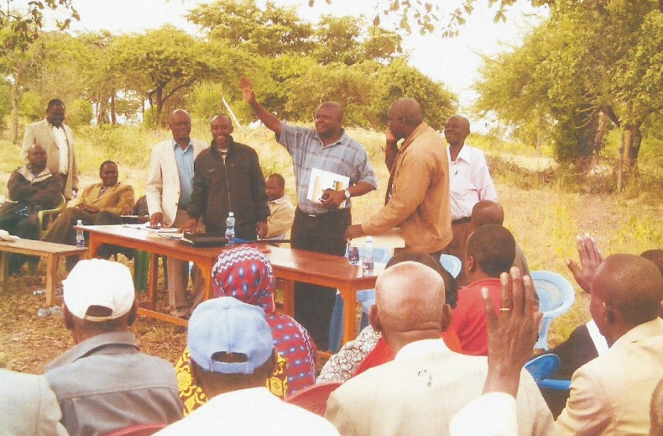Out of approximately 1,8 00,000 million unemployed people in Kenya today, 60% are under the age of 30 years with young women having a much higher unemployment rates than men. And this lack of employment leads to further problems in the society. While crime rates are dropping, over 50% of all convicted criminals in Kenya are young males aged between 16 and 25 years with most crimes committed being financially motivated (IEA 2010). Kenya YMCA's economic renaissance programmes tackle this challenge by helping members secure their livelihoods, develop their employment potential and build entrepreneurship skills.

Kondo YMCA is running one such programme achieving massive impact on helping to secure livelihoods. With funding from the National Irrigation Board worth Kshs. 24 million, the project is providing irrigation to 50 agribusinesses and family farms in the semi-arid region reducing the risk of harvest failure. 200 drip kits have been distributed and the project continues to link even more farms in the region up to the community-scale irrigation system.

Farmers at a project meeting in Kondo

Shauri Moyo YMCA partnered with the African Alliance of YMCA and Junior Achievement to deliver a
12-week entrepreneurship course to 40 young people. Participants gained skills in business planning and understanding the legal process of registering their own company.

Kilifi YMCA has established a number of self-help groups for women. These groups bring together members of the community to pool their resources for individual and community development enabling often extremely poor, rural families to be able to afford their basic needs such as food, clothes and shelter. The branch is now coordinating 71 groups with success stories emerging all the time. Kahaso Tsofa is a member of Jeza Zhomu Self Help Group aged 78. She joined the group in June 2007 then in 2008 sustained a leg and spinal code injuries which kept her in hospital for 3 months. The group purchased her crutches and she received a loan to re-build her house once more.

Mombasa YMCA held a careers forum for 57 youths in November to support young people - especially those who had just completed their O-level exams - in making informed career choices. Topics covered including: how to get support from youth networks, Curriculum Vitae preparation, interview skills and business start-up and entrepreneurship, understanding business concepts such as income, expenditure, profit and loss accounts.

Kisumu YMCA facilitated the growth of “Milimani Young Achievers”, a youth-led group of 10 members who came together with the common goal of taking action on sustainability in their lives. In 2013 the group combined what they had learned in business and finance training provided by Junior Achievement with training on bird rearing from Kenchic staff to establish a poultry farm at the branch. Specialising in broilers, the group now earns some good income supplying hotel restaurants in Kisumu City.

Nakuru YMCA, in partnership with the Population Council, reached out to 1,800 young girls with an aim of developing financial saving skills and Indangalasia YMCA has been established as a training centre on how to access and apply for the Government's Uwezo Fund.

Services

Kenya YMCA continues to provide a wide array of services for the communities it serves. In 2013, the following programmes and services were provided:

Early Childhood Development Centres, Primary and Secondary School education

Kenya YMCA provides early childhood development centres in eight locations across the country: Thika, Busia, Naivasha, Kilifi, Kondo, Nyeri (two) and Ngecha. It also provides primary and secondary level education to 1,204 students at Kibera, Shauri Moyo, Busia and Nakuru.

Kibera is one of the largest slums in Africa, with a significant number of street children. Many parents lack the ability to fully cater for the basic needs of their children which leads to them either dropping out of school or a sharp decline in performance.

The YMCA school in Kibera is tackling this through an education sponsorship scheme for 20 pupils with the financial support of Baden YMCA - Germany. Eight students who performed particularly well in the 2012 class Eight are being sponsored by Ottawa Y's Mens Club in Canada to pursue their high school studies.

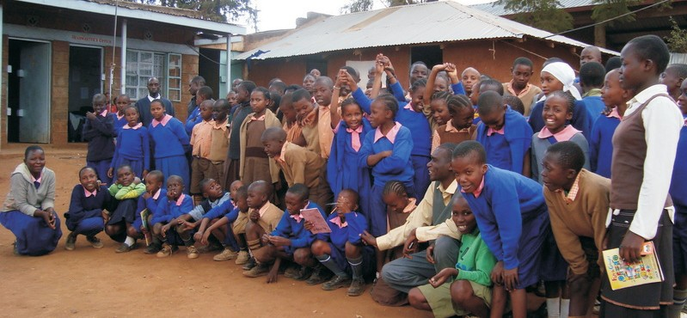Pupils at Kibera YMCA School

Hi Y Clubs are school, college or church-based groups attracting members between the ages of 13 and 18. Run by volunteer Youth Leaders, Hi Y Clubs are designed to develop the life skills of their members: developing a sense of self, building character, raising academic aspirations, creating channels for community involvement/ service, and developing and enhancing leadership skills. There are now
14 Hi Y Clubs across Kenya running activities including: debates/ open forums, life skills training, group activities to improve team work, community service e.g. clean up days and environmental conservations, trainings and camping, hiking, excursion and exchange programmes

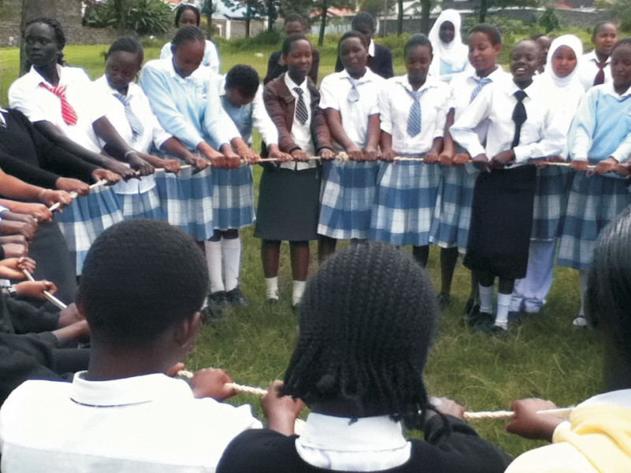Youth participate in an ice breather activity at a Hi Y club

Vocational Training Centre’s

Kenya YMCA has 629 students in six Vocational Training center’s country-wide (Nairobi South/ Kibera, Thika, Kisumu, Meru, Mombasa, Nyeri) studying a wide-range of subjects including, tailoring, motor vehicle mechanics, agriculture, and electrical wiring computer packages among others.

In addition, the National Training Institute (NTI) at Shauri Moyo YMCA in Nairobi serves 400 students and has grown from strength-to-strength. In 2013 the following milestones were registered;
- There was a straggering increase in enrolment with 60 pupils in 2012 increasing to 262 in 2013
- All students who took final exams in 2013 also undertook entrepreneurship training in line with
Ministry of Education guidelines.
- A number of new courses were introduced in line with its mandate to expand its courses portfolio including: Diploma in Electrical Engineering, Craft in Electrical Installation, Diploma in Civil Engineering, Diploma in ICT, Craft Certificate in ICT.
- The Institute formally registered as a teaching and examining Centre for Institute of Commercial Management (ICM), a body based in the UK. This placed NTI in a position to be the preferred Centre in Nairobi region and many students even from other colleges take their exams in NTI.

Kenya YMCA College of Agriculture & Technology also dramatically improved performance with 175 registered students in 2013, an increase of 68% from 104 in 2012. The College has 100% employment rate and with new courses in 2013 including Animal Health Science (Production) and Electrical Installation it is hoped number of students will increase tremendously. To enhance student participation in the governance of the college, a student council was formed in June, 2014 where the students had the opportunity to choose their leaders.

Health

Kenya YMCA continues to be highly active in supporting the provision of professional health care to their communities, providing space and facilities for the holding of medical camps and HIV/ AIDS awareness- raising programmes among others. Naivasha YMCA ran a youth-led training session on drug abuse.

Kilifi YMCA, with a Kshs. 350,000 grant from National Aids Control Council, Kilifi YMCA delivered a six month Voluntary Counselling and Testing programme targeting the most at risk populations including: drug users, sex workers, fish mongers, long distance drivers and homosexuals. During the entire period of the project over 1,900 people were tested.

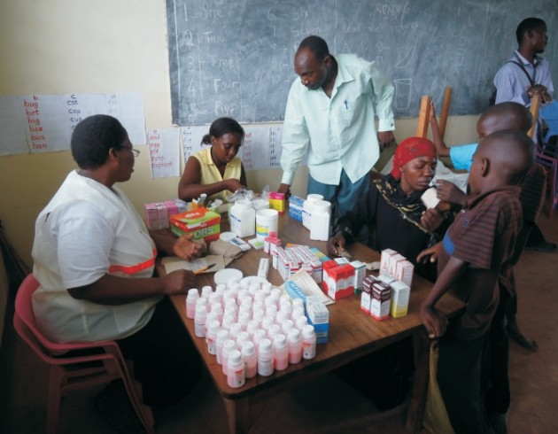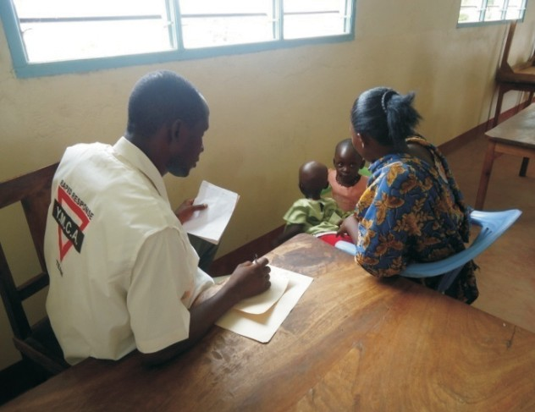Mombasa YMCA held a free medical camp in April for Mreroni residents who are far from health facilities. Partnerships with World Vision, Sheki FM Radio and Big Dreams CBO made the whole day a huge success. Other initiatives over the year included two health talks in schools and the distribution of reusable sanitary towels to girls in Mau Mau Girls and Hirimani secondary school.

Sports and recreation

A wide range of sports and recreation activities are provided at various YMCA branches across the country thereby offering young people a safe way to use their spare time, nurture their talents and build life skills such as discipline and team-work in addition to staying fit and healthy.

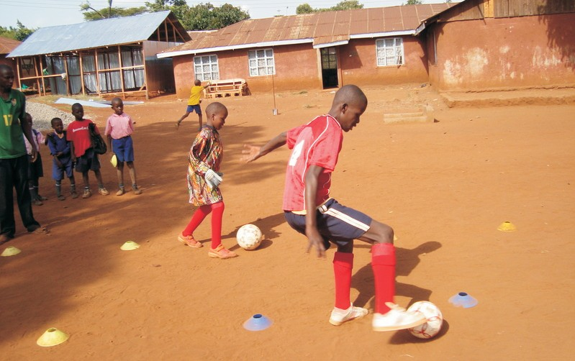Many YMCA branch teams have participated in regional and national sporting events with some success. The Kisumu YMCA Karate club members participated in National Champions Tournament and emerged the best team Nationwide.

Advocacy

Kenya YMCA works to facilitate young people to advocate for both their rights and for their opinions on the critical issues of the day.

With the introduction of the devolved County governments, the opportunities for advocacy activities and the ability to influence public policy and resource allocation - both by, and on the behalf, of young people have opened up. A significant achievement was the appointment of two Nakuru YMCA members to the county committee for youth issues.

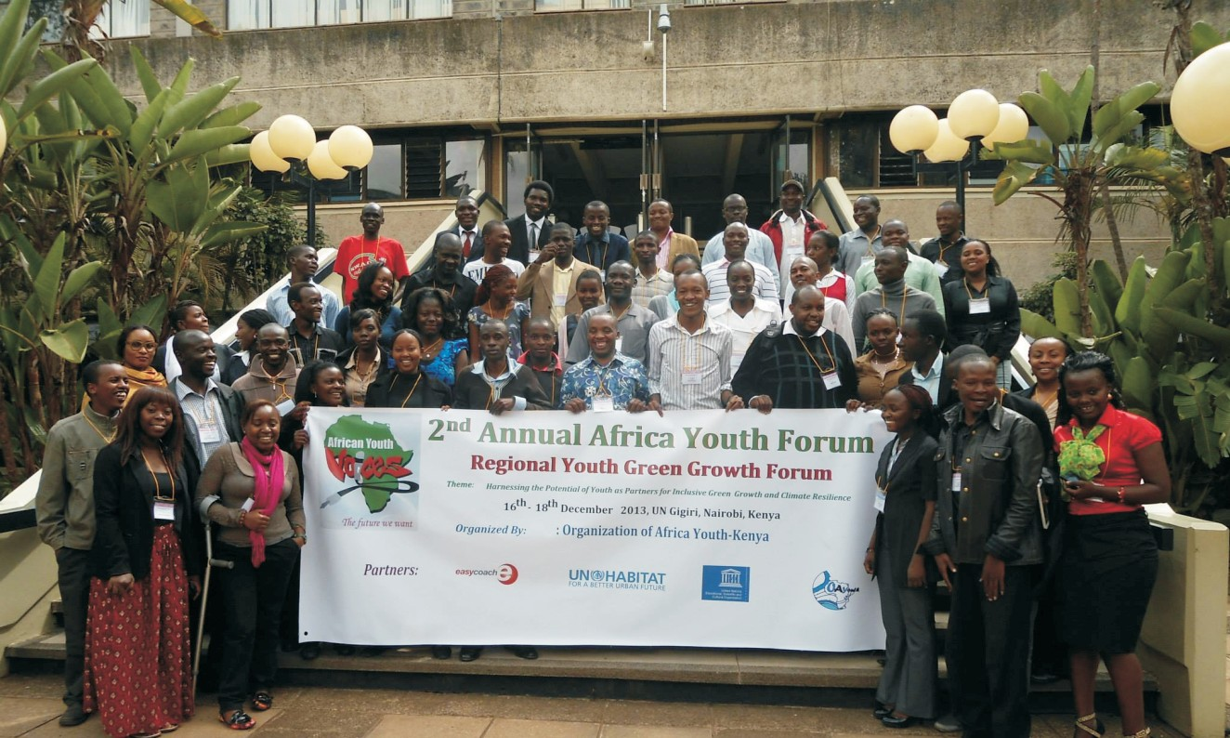At the international level, climate change is high on the post-2015 development agenda and many branches are finding ways to help young people have their voice heard in the forums discussing how to tackle this global challenge. Nairobi Central has led the way with a huge variety of activities including submitting position paper on the UN's REDD+ programme (Reducing emissions from deforestation and forest degradation), high-level engagement on citizen issues at C.O.P 19 in Poland, meeting the Cabinet Secretary and Climate Change Working Group to lobby for the revival of the Climate Change Bill, sending participants to the Regional Youth Green Growth Forum in September, and the appointment of a YMCA member to be Youth County Advisor on Environment issues.

Youth at the 2nd Annual Africa Youth Forum on Green Growth

Refurbishing the “home away from home”

Each branch of Kenya YMCA aims to be a “home away from home” for young people and members of the community; places where needs can be met and potential nurtured. To make sure that YMCA fulfils this role a number of significant capital development and refurbishment projects were undertaken in 2013.

Kibera YMCA achieved the significant milestone of constructing permanent classroom structures with the significant financial support of well over Kshs.700,000 from Ottawa Y's Men Club based in Canada led by Y’s Man David Hall. The financial support would not have been possible without the connection of Past International Vice President of Y's Men International –PIVP Stanley Kinyeki. Through this connection more financial support is expected in the course of the year to construct additional eight classrooms.

The centre has become an Island in Kibera slums because it offers a conducive learning environment for the pupils and the entire staff. What's more, thanks to the THREE T's Time, Talent and Treasure provided by PIVP Stanley Kinyeki for the benefit of poor children in Kibera Slums.

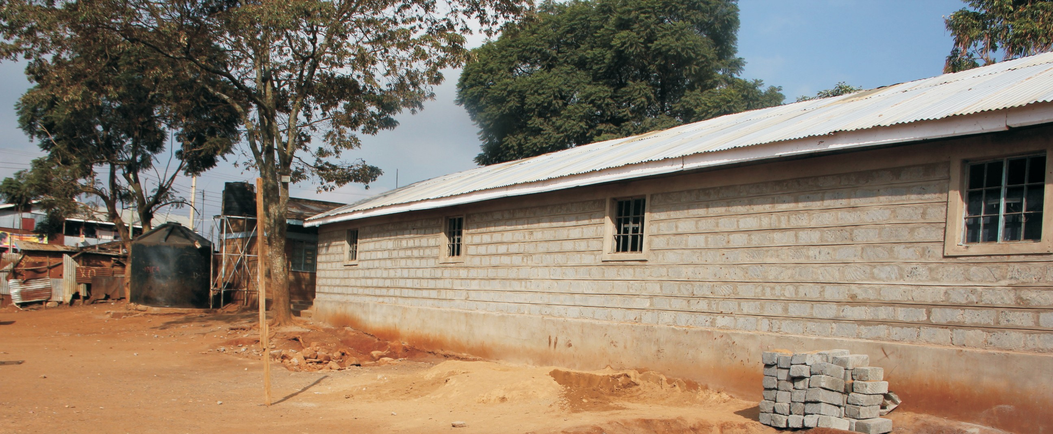New School Building at Kibera

At Shauri Moyo YMCA the refurbishment of the roof of the community hall - generously funded by the Safaricom Foundation in collaboration with Kenya YMCA - is almost complete and the benefits are now being felt by many:

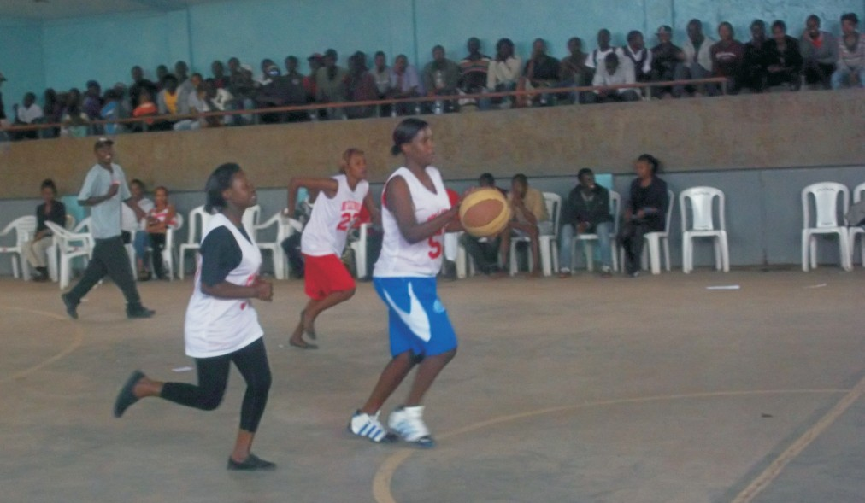Kevin Omondi: The gymnasium has been of tremendous help to our volleyball team. Being members of the branch, we have the privilege of enjoying the facility free of charge. It has aided in the development of the volleyball sport in the region as most of our members have ended up being recruited in the various teams and some being recruited to the national team. Many youth members have joined the volleyball team hence staying away from bad influential gangs.

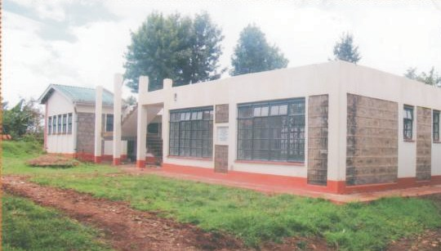Githumu YMCA registered a remarkable success of raising significant funds (Kshs.300,000 )from the local community and Y's Men International who funded the project to the tune of Swiss Franc.30,000 (Approximately Kshs.2,400,000) in order to build a new and magnificent community library. Kenya YMCA contributed Kshs.987,000 to complete the building. The task for 2014 is to raise further resources to equip the building with desks, chairs and books so that pupils can take full advantage of the new facilities.

Strengthening Kenya YMCA

The Kenya YMCA Peer Review was held from the 23rd to the 28th September 2013 in Nairobi and was the second peer review to be held in the Eastern/Southern Zone.

The African Alliance of YMCAs introduced the peer review mechanism (PRM) with the goal of strengthening national movements, by bringing them together to analyse performance and share best practice.

A baseline survey was undertaken to determine the current situation of Kenya YMCA in relation to its structures, governance systems and tools, communications, programmes, finances, networking and partnerships. At the end of the process, recommendations were made by the peer review team to enable Kenya YMCA to grow and improve.

Participants of the peer review in Kenya were drawn Zambia, Madagascar, South Sudan, Ethiopia and
Tanzania.

Milestones in Kenya YMCA's history were noted including:

- Participation in Kenya Constitution review process between 1997 – 2004 and YMCA leaders participated in aligning national values in the Kenyan new constitution
- Contribution the development of national youth policy from 2001- 2005
- A leading role in the establishment of the African Alliance of YMCA office in Kenya through constitution formulation and provision of land to house AAYMCAs
- Well over 13,000,000 people have benefited from YMCA programmes since its inception in 1910
- The Subject 2 Citizen philosophy was piloted in four Branches within Kenya YMCA in the early stages of its adoption by YMCA movements across Africa

In the final analysis, the following recommendations were made for movement strengthening:

- Establish realistic but stretching membership targets
- More prominent display of the Kenya YMCA vision in strategic places
- Enhance the leadership and communicate strategies
- Develop a gender policy that aligns with that of the Africa Alliance of YMCA
- Set a time frame for constitution amendments and renewals
- Form a membership recruitment committee
- Use a reward mechanism strategy to motivate the youth members
- Wider embrace of the s2c philosophy

We would like to thank all participants of the Peer Review for their insight, support and encouragement. As Kenya YMCA moves forward into 2014 and beyond we look forward to implementing these recommendations and growing in strength and size.

KENYA YOUNG MEN'S CHRISTIAN ASSOCIATION STATEMENT OF NATIONAL EXECUTIVE COMMITTEE'S RESPONSIBILITIES FOR THE YEAR ENDED 31st DECEMBER, 2013

The Non-Governmental Organization Co-ordination Act requires the Executive Committee to prepare financial statements for each financial year that give a true and Fairview of the state of affairs of the organization as at the end of the financial year and of its operating results for that year. It also requires the Executive Committee to ensure that the organization maintains proper accounting records which disclose, with reasonable accuracy, the financial position of the organization. The Executive Committee is also responsible for safeguarding the assets.

The Executive Committee accept responsibility for the financial statements, which have been prepared using appropriate accounting policies supported by reasonable and prudent judgments and estimates, in conformity with International Financial Reporting Standards and the requirements of the Non- Governmental Organization Co-ordination Act. The Executive Committee is of the opinion that the financial statements give a true and fair view of the state of the financial affairs of the organization as at
31st December, 2013 of its operating results for the year then ended. The Executive Committee further
accept responsibility for the maintenance of accounting records which have been relied upon in the preparation of the financial statements, as well as on the adequacy of the systems of internal financial controls.

Nothing has come to the attention of· the Executive Committee to indicate that the organization will not remain a going concern for at least the next twelve months from the date of this statement.

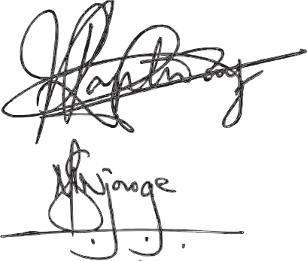Approved by the board of Executive Committee on 10th May 2014 and signed on its behalf by:

Chairman ......................................................................... Treasurer ..........................................................................

TREASURER'S REPORT ON THE FINANCIAL PERFOMANCE OF KENYA YMCA FOR
THE YEAR ENDED 31 DECEMBER 2013

PREAMBLE:
The year 2013 was a year full of activities and situations that impacted on the organisation both positively
and negatively. The country experienced diverse mix of political and economic challenges that resulted
into a slow down of economic activities in all the sectors.

The challenges that our country faced during the year were diverse and real. They ranged from high rate of unemployment, inflation dynamics, uncertainty and the frequent unexpected life threatening incidents triggered by terrorists. The result of these challenges was erosion of the spending capacity of our citizens.

The Kenya YMCA was not spared with the foregoing challenges hence the slowed down development and growth within the organisation. Despite the unstable and unpredictable socio-economic environment, Kenya YMCA remained resilient and afloat. This was achieved mainly because of sound leadership coupled with prudent administration and financial management.

Accordingly, the year 2013 registered remarkable achievements in terms of financial growth and overall sustainability of the organisation. This was evidenced in local contributions which increased by Kshs.
14,896,788.00, from Kshs. 159,176,537.00 in 2012 to Kshs. 174,073,325.00 in the year 2013. This represents a 9.4% increase. This increase is mainly attributed to the continuous improvements made on our facilities as well as improved service delivery. Despite the high operating costs, the deficit dropped from Kshs. 232,030.00 in the year 2012 to Kshs. 117,687.00 in the year 2013. This represents a 49% drop in previous year's deficit.

Below is an over view of what transpired during the year 2013.

CAPITAL PROJECTS:

During the year 2013, major projects were undertaken. These include refurbishment and upgrading a number of our facilities such as Shauri Moyo gymnasium, Nairobi Central hostel rooms, swimming pool, Kibera classes and Githumu library among others. The children's recreation park was developed at a cost of Kshs. 1,500,000.00 and is expected to attract many children and their parents especially during school holidays. New gym equipment has also been acquired.

These are ongoing developments that are being spread out gradually to local YMCA branches as well. Primarily this will give YMCA facilities a facelift thereby attracting more clientele and consequently generating more revenue for funding youth development programmes.

PERFORMANCE HIGHLIGHTS:

Thika YMCA Branch generated total revenue of Kshs. 2, 521,612.00 in the year 2013 against an expenditure of Kshs. 3,726,155.00 hence making a deficit of Kshs. 1,204,543.00. In the year 2012, the branch generated a surplus of Kshs. 391,959.00.

Busia YMCA Branch generated total revenue of Kshs. 1,431,105.00 in the year 2013 against an expenditure of Kshs. 1,881,125.00 hence making a deficit of Kshs. 450,020.00. In the year 2012 the branch had generated a surplus of Kshs. 444,388.00.

Mombasa YMCA Branch generated total revenue of Kshs. 1,546,608.00 in the year 2013 against an expenditure of KSHS. 1,446,642.00 hence making a surplus of Kshs. 99,966.00. In the year 2012 the branch registered a deficit of Kshs. 82,328.00.

Kilifi YMCA Branch generated total revenue of Kshs. 365,300.00 in the year 2013 against an expenditure of Kshs. 422,706.00 hence making a deficit of Kshs. 57,406.00. In the year 2012 the branch generated a surplus of Kshs. 54,770.00.

Nairobi Central YMCA Branch generated total revenue of Kshs. 1,262,558.00 in the year 2013 against an expenditure of Kshs. 1,365,099.00 hence making a deficit of Kshs. 102,541.00. In the year 2012 the branch recorded a surplus of Kshs. 928,643.00.

Shauri Moyo YMCA Branch generated total revenue of Kshs. 9,700,980.00 in the year 2013 against an expenditure of Kshs. 9,111,131.00 hence making a surplus of Kshs. 589,849.00. In the year 2012 the branch generated a surplus of Kshs. 180,048.00.

Meru YMCA Branch generated total revenue of Kshs. 6,181,852.00 in the year 2013 against an expenditure of Kshs. 7,123,519.00 hence making a deficit of Kshs. 941,667.00. In the year 2012 the branch made a surplus of Kshs. 1,365,765.00.

Nyeri YMCA Branch generated total revenue of Kshs. 40,050.00 in the year 2013 against an expenditure of Kshs. 319,374.00 hence making a surplus of Kshs. 220,676.00. In the year 2012 the branch generated a surplus of Kshs. 107,237.00.

Nairobi Central YMCA Hostel generated total revenue of Kshs. 51,843,786.00 in the year 2013 against an expenditure of Kshs. 51,289,419.00 thereby making a surplus of Kshs. 554,367.00. During the year 2012 the hostel generated a surplus of Kshs. 1,106,719.00.

Lake Naivasha YMCA Camp generated total revenue of Kshs. 2,932,462.00 in the year 2013 against an expenditure of Kshs. 2,896,931.00 making a surplus of Kshs. 35,531.00. In the year 2012 the camp made a deficit of Kshs. 295,392.00.

The swimming pool generated total revenue of Kshs. 6,942,850.00 in the year 2013 against an expenditure of Kshs. 6,305,269.00 leaving a surplus of Kshs. 637,581.00. In the year 2012 the swimming pool registered a deficit of Kshs. 1,230,831.00.

Educational and Vocational Training Programmes generated total revenue of Kshs. 28,618,745.00 in the year 2013 against an expenditure of Kshs. 27,977,216.00 registering a surplus of Kshs. 641,529.00. In the year 2012 a deficit of Kshs. 421,371.00 was registered.

CONCLUSION:

The challenges that the Kenya YMCA faces are not insurmountable. The performance as indicated in financial report for the year ended 31st December 2013 is a clear indication that the YMCA can sustain itself even in the face of adversity. The 9.4% increase in local contributions is evidence that YMCA remains attractive to existing and new members. The recovery from a deficit of Kshs. 421,371.00 in the year 2012 to a surplus of Kshs. 641,529.00 in the year 2013 in our educational and vocational training programmes indicates that our programmes are competitive, relevant and the students continue to benefit through knowledge and skills acquisition. Similarly, the swimming pool recovery from a deficit of Kshs. 1,230,831.00 in the year 2012 to a surplus of Kshs. 637,581.00 in the year 2013 is a clear testimony that continuous refurbishment of YMCA sports and recreation facilities will continue to attract more clients.

The Kenya YMCA has remained focused on continuously making relevant improvements in terms of facilities upgrading that are consistent with the present demands and anticipated future demands. This focus will no doubt continue to propel the YMCA to self reliance as opposed to always expecting large donor funding.

Progressive computerization of our financial systems and training of respective staff has continuously yielded desired results of prompt and more accurate report generation.

As we strengthen the existing programmes and activities, let us also be courageous enough to venture into new and more creative, attractive and relevant youth development programmes and activities. Let us all actively pursue the goal of improving the financial health of Kenya YMCA so that we grow our youth development programmes and continue to attract more members thereby expanding our opportunities to make meaningful impact in the lives of the youth in this country.

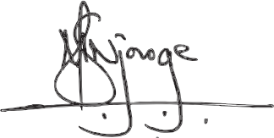

SILAS NJOROGE
NATIONAL HONORARY TREASURER

KENYA YOUNG MEN'S CHRISTIAN ASSOCIATION REPORT AND FINANCIAL STATEMENTS
CONSOLIDATED STATEMENT OF COMPREHENSIVE INCOME FOR THE YEAR ENDED 31 DECEMBER 2013

INCOME
2013 2012
KES. KES.

Local Contributions | 174,073,325 |  | 159,176,537
Grants Received | 3,735,735 |  | 6,688,879
TOTAL INCOME | 177,809,060 |  | 165,865,416
EXPENDITURE
Personnel Expenses | 67,553,604 |  | 63,283,162
Administration Expenses | 17,276,357 |  | 15,164,306
Programme Activities | 85,862,000 |  | 79,783,382
Financial Expenses | 1,272,963 |  | 1,363,739
Depreciation | 6,003,041 |  | 6,196,273
TOTAL EXPENDITURE | 177,967,965 |  | 165,790,862
(DEFICIT)/SURPLUS | (158,905) |  | 74,554
Prior Year Adjustment | 41,218 |  | (306,584)
DEFICIT | (117,687) |  | (232,030)

KENYA YOUNG MEN'S CHRISTIAN ASSOCIATION REPORT AND FINANCIAL STATEMENTS CONSOLIDATED STATEMENT OF FINANCIAL POSITION AS AT 31 DECEMBER 2013

ASSETS

2013 2012

Non-current Assets KES. KES.
Property, Plant & Equipment | 3,739,531,517 |  | 3,750,673,382
Investment | - |  | 7,589
 | 3,739,531,517 |  | 3,750,680,971
Current Assets  Stocks | 1,360,286 |  | 1,143,088
Biological Assets | 1,918,760 |  | 1,891,650
Debtors and Prepayments | 28,960,737 |  | 23,369,571
Deposits | 1,741,812 |  | 1,618,506
Fixed Bank Deposits | - |  | 169,270
Cash at Hand and in Bank | 8,766,512 |  | 3,228,524
Total Current Assets | 42,748,107 |  | 31,420,608

TOTAL ASSETS | 3,782,279,624 |  | 3,782,101,579
LIABILITIES AND GENERAL FUND
Capital and Reserves
General Fund | 78,664,636 |  | 94,296,515
Capital fund | 7,549,549 |  | 3,770,628
Designated Fund | 2,193,930 |  | 2,287,430
Revaluation Reserve | 3,670,517,706 |  | 3,653,764,794
 | 3,758,925,820 |  | 3,754,119,367
Non-current Liabilities
Loan | 442,800 |  | 756,035
Current Liabilities  Bank Overdraft | 1,452,425
Creditors and Accruals | 21,458,578 |  | 27,226,177
 | 22,911,004 |  | 27,226,177
TOTAL LIABILITIES AND GENERAL FUND | 3,782,279,624 |  | 3,782,101,579

The accounts presented in this report were approved by the National Executive Committee on
10th May 2014 and were signed on its behalf by :

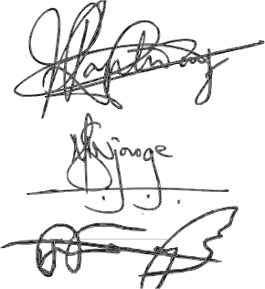MR. PATRICK KAPTWAY - Chairman Nat. Exec. Committee ..................................... MR. SILAS NJOROGE - Hon. Treasurer ..................................... MR. JARED MUSIMA - National General Secretary .....................................

REPORT OF THE INDEPENDENT AUDITOR
TO THE MEMBERS OF YOUNG MEN'S CHRISTIAN ASSOCIATION

Report on the Financial Statements
We have audited the accompanying financial statements of Young Men's Christian Association set out on
pages 8 to 22 which comprise the statement of financial position as at 31 December 2013, and the
statement of comprehensive income, statement changes in equity and cash flow statement for the year
then ended, and a summary accounting policies and other explanatory notes.

Executive Committees' responsibility for the Financial Statements
The Executive Committee is responsible for the preparation and fair presentation of these financial
statements in accordance with International Financial Reporting Standards and the requirements of the
Non-Government Organizations Co-ordination Act. This responsibility includes: designing, implementing
and maintaining internal control relevant to the preparation and fair presentation of financial statements
that are free from material misstatement, whether due to fraud or error; selecting and applying appropriate
accounting policies; and making accounting estimates that are reasonable in the circumstances.

Auditor's Responsibility
Our responsibility is to express an independent opinion on these financial statements based on our audit.
We conducted our audit in accordance with International Standards on Auditing. Those standards require
that we comply with ethical requirements and plan and perform the audit to obtain reasonable assurance
whether the financial statements are free from material misstatement.

An audit involves performing procedures to obtain audit evidence about the amounts and disclosures in the financial statements. The procedures selected depend on the auditor's judgment, including the assessment of the risk of material misstatement of the financial statements, whether due to fraud or error. In making those risk assessments, the auditor considers internal control relevant to the entity's preparation and fair presentation of the financial statements in order to design audit effectiveness of the organization's internal control. An audit also includes evaluating the appropriateness of accounting policies used and the reasonableness of estimates made by the executive committee, as well as evaluating the overall presentation of the financial statements.

We believe that the audit evidence we have obtained is sufficient and appropriate to provide a basis for our audit opinion.

Opinion
In our opinion the accompanying financial statements give a true and fair view of the state of the financial affairs of the Organization as at 31st Dec. 2013 and of its surplus and cash flows for the year then ended in
accordance with International Financial Standards and the requirement of the Non-Governmental
Organizations Co-ordination Act.

Report on Other legal Requirements

We report to you that:

i) We have obtained all the information and explanations which to the best of our knowledge and belief were necessary for the purpose of our audit;

ii) In our opinion, proper books of account have been kept by the organization, so far as appears from our examination of those books: and

iii) The organization's statement of financial position and statement of comprehensive income are in agreement with the books of account as currently maintained.

The engagement partner responsible for the audit resulting in this independent auditor's report is CPA Daniel Kagunda Kabiru - P/NO 1904.

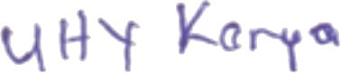

Certified Public Accountants
Nairobi

1 1 May 2014

National leaders of Kenya YMCA

The National Executive Committee of the Kenya YMCA is comprised of six members, six officers, up to five registered Trustees elected by the National Council and Chairmen/Persons of the National Standing Committees appointed by the National Executive Committee. In 2013, the YMCA leadership was as follows:

OFFICERS OF THE NATIONAL COUNCIL OF KENYA YMCA

Mr. John Ombija National Chairman
Mrs. Joan Muoti National Vice Chairperson
Mr. John Munyua National Vice Chairman
Mr. Silas Njoroge National Honorary Treasurer

NATIONAL EXECUTIVE COMMITTEE

Mr. Patrick Kaptway Chairman
Ms. Praxidice Saisi Vice Chairperson
Mr. Tom Waka Member Ms. Faith Otieno Member Ms. Irene Ayimba Member Mr. John Wambua Member Ms. Lilian Kang'ethe Member Mr. Kefas Kahaso Member

CHAIRPERSONS OF NATIONAL STANDING COMMITTEES

Mr. Eliud Mambo Board of Trustees
Mr. Silas Njoroge Resource and Property Development Committee
Mr. Phillip Munyua Christian Emphasis & Ecumenical Relations Committee
Ms. Irene Ayimba National Youth Committee
Mr. Michael Mwangi Board Chairman – Limuru Agricultural Youth Centre
Mr. Ben Kikuvi National Nominations Committee
Mrs. Margaret Musima Leadership Development Committee
Mr.Tom Waka Educational & Skills Development Committee
Mr. John Ombija Finance, Human Resource & Procurement Committee

TRUSTEES

Mr. Eliud Mambo Mr. Alfred Lulu Mr. Ben Kikuvi
Rev. Dr. Charles Kibicho
Mrs. Margaret Musima

Directory of Kenya YMCA Groups, Branches and Units

BRANCH |  | ADDRESS | TELEPHONE
1. | Busia YMCA | P.O. Box 495 - 50400, Busia | 0712945562
2. | Chavakali YMCA | P.O. Box 1237 – 50300, Maragoli
3. | Githumu YMCA | P.O. Box 263 -10218, Kangari | 0711 894 307
4. | Indangalasia YMCA | P.O. Box 371 - 50102, Mumias | 0726 071 424
5. | Kilifi YMCA | P.O. Box 277 – 80108, Kilifi | 0737 173 670
6. | Kondo YMCA | P.O. Box 06 -90124, Kithimani | 0711 570 814
7. | Kisumu YMCA | P.O. Box 1848 – 40100, Kisumu | 0721 900 829
8. | Meru YMCA | P.O. Box 204 – 60200, Meru | 0723 840 028
9. | Mombasa YMCA | P.O. Box 85744 - 80100, Mombasa | 0727 742 695
10. | Mugona YMCA | P.O. Box 712 -60400, Chuka | 0712 832 007
11. | Nairobi Central YMCA | P.O. Box 63063 – 00200 Nairobi | 2724116/7
12. | Nairobi South YMCA | P.O. Box 59260 -00200, Nairobi | 0727 624 116
13. | Naivasha YMCA | P.O. Box 359 – 20117, Naivasha | 0724 905 200
14. | Nakuru YMCA | P.O. Box 7284 - 20100, Nakuru | 0721 174 828
15. | Ngecha YMCA | P.O. Box 73 – 00218, Ngecha | 0723 404608
16. | Nyeri YMCA | P.O. Box 192 - 10100, Nyeri | 0721 331299
17. | Shauri Moyo YMCA | P.O. Box 17073 -00510, Nairobi | 0723 504 435
18. | Thika YMCA | P.O. Box 330 – 0100, Thika | 0720 937 952

 | UNITS | ADDRESS | TELEPHONE
1. | Naivasha YMCA Camp | P.O. Box 1006 -20117, Naivasha | 050 5109
2. | Nairobi Central YMCA Hostel | P.O. Box 63063 – 00200 Nairobi | 2724116/7
3. | Nairobi South YMCA Hostel | P.O. Box 59260 - 00200, Nairobi | 0721 520 022
4. | Shauri Moyo YMCA Hostel | P.O. Box 17073 – 00510, Nairobi | 0727 488 393
5. | Limuru Agricultural Youth Centre | P.O. Box 30496 – 00100, Nairobi | 020 2012283
6. | YMCA National Training Institute - Shauri Moyo | P.O. Box 17073 - 00510, Nairobi | 0721 501 642
7. | Nairobi Central Swimming Pool | P.O. Box 63063 - 00200, Nairobi | 2724116/7
8. | YMCA Cyber Café | P.O. Box 30330 – 00100, Nairobi | 2724116/7

YMCA BRANCH | YEAR FOUNDED
Kenya YMCA | 1910
Busia | 1972
Chavakali | 1976
Gatuatine | 1980
Githumu | 1976
Indangalasia | 1977
Kakamega | 1976
Kisii | 1977
Kisumu | 1971
Meru | 1958
Mombasa | 1954
Mugona | 1977
Nairobi Central | 1910
Nairobi South | 1976
Nakuru | 1960
Naivasha | 1961
Ngecha | 1958
Nyeri | 1959
Sagana | 1980
Shauri Moyo | 1952
Siaya | 1976
Thika | 1964

