KENYA YOUNG MEN’S CHRISTIAN ASSOCIATION (KENYA YMCA)
STRATEGIC PLAN 2020/2023



National Executive Committee Members

©October 2020

Vision

Empowering young people for the African Renaissance

Mission

We exist to facilitate and enhance development of the physical, mental and spiritual well-being of youth as productive and responsible citizens

Core Values

F o u n d e d i n T r i n i t y,
Professionalism,
Volunteerism,
I n c l u s i v i t y,
Creativity,
Integrity,
Equity

Background - Kenya YMCA
Kenya YMCA was founded in 1910 and is a voluntary, non-denominational and not-for-profit making organization. Kenya YMCA attracts members from all religions, races, gender and social strata.
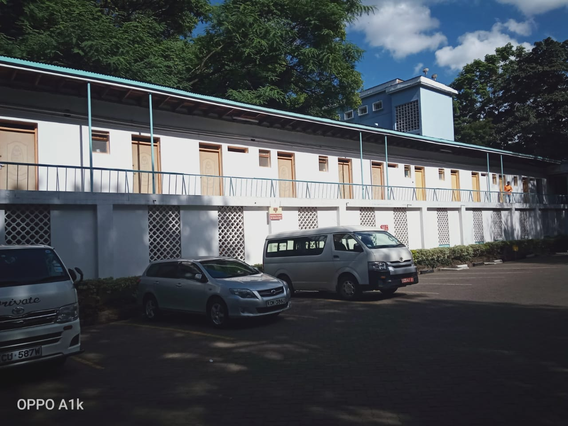
Kenya YMCA is affiliated to World Alliance of YMCAs and Africa Alliance of YMCAs and is a charitable membership organization committed to the improvement of the quality of life of all the youth both in rural and urban areas. It is found in 15 counties across the Country with branches in Nairobi Central, Nairobi South C, Shauri Moyo, Ngecha, Githumu, Busia, Chavakali, Indangalasia, Kisumu, Nakuru, Naivasha, Nyeri, Thika, Meru, Mugona, Kondo, Anyiko, Mombasa and Kilifi. The Association also have learning institutions namely Chavakali ECDE, Mugona ECDE, Kibera ECDE, Kibera Primary School, Shauri Moyo Primary School, Nakuru Secondary School, Kenya YMCA College of Agriculture and Technology, National Training Institute, Kisumu Vocational Centre and Meru College of Accountancy
In line with the mission of the worldwide YMCA movement, Kenya YMCA seeks to develop young people in the three dimensions namely; body, mind and spirit. It provides opportunities to develop the body through sports and other forms of active leisure, develop the mind through trainings and skills formations, and the spirit through various Christian teachings and activities. Kenya YMCA is implementing various programmes and activities in life skills development, camping, vocational training, capacity building programs, character transformation activities, sports and recreation, early childhood and primary school education, women empowerment, health programmes including drug and substances abuse prevention, civic competence, skills development, education and nurturing activities.

Governance

STRATEGIC PILLARS, OBJECTIVES AND ACTIVITIES

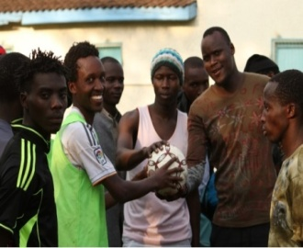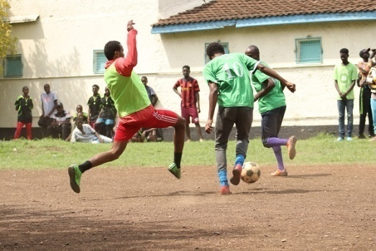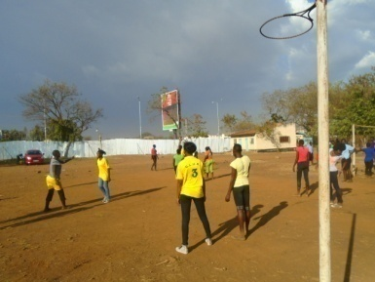
Kenya YMCA Sports Day

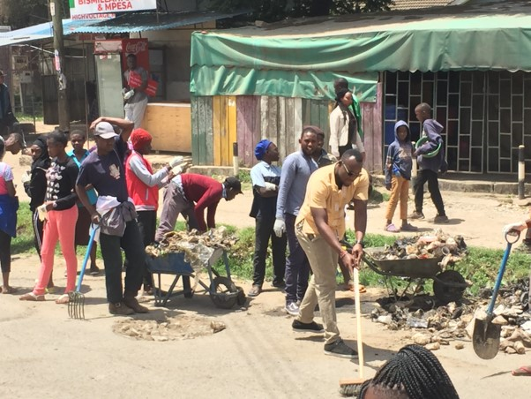
Youth Care for Environment

MEMBERSHIP, LEADERSHIP&SPIRITUAL DEVELOPMENT PILLAR
- To expand and strengthen Kenya YMCA membership base by recruiting 26,300 members within the plan period
- To enhance the leadership capacities of 2,630 members of Kenya YMCA within the plan period
- To strengthen Christian Emphasis Programmes at all levels of the Kenya YMCA
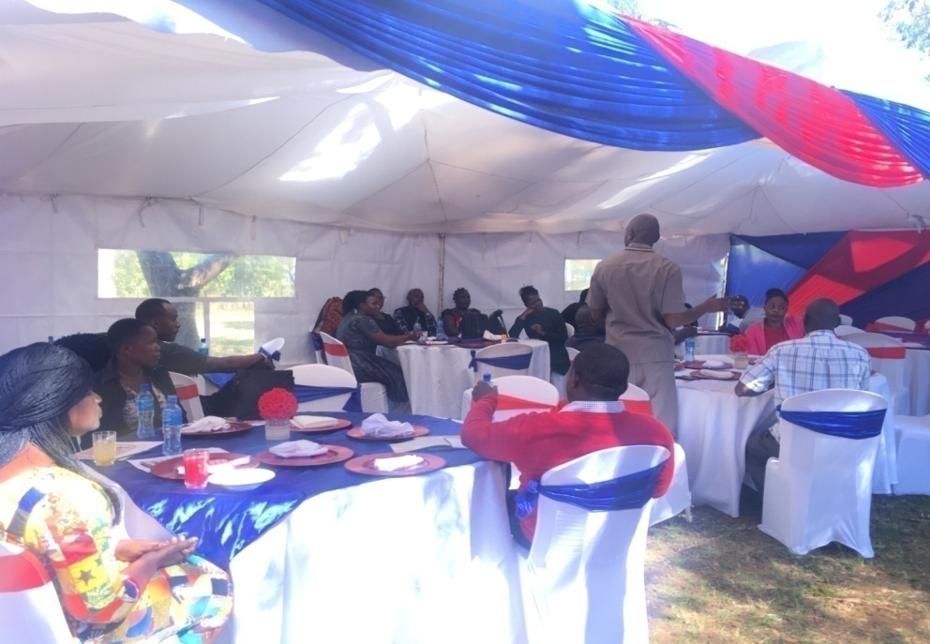
Kenya YMCA Membership Day
Kenya YMCA Christian Outreach Programme in Prison

Specific Objective(s) | Actionable  Strategy | Activities
To expand and strengthen Kenya YMCA membership base by recruiting 26,300 members within the plan period | Review of Kenya YMCA Membership Strategies | -Form membership review committee to look at Kenya YMCA Membership recruitment and retention Strategies, Policies, Categories & fees for different youth, and membership category & fees within Kenya YMCA’s schools and colleges
 | Recruitment, Orientation and induction of membership | Recruit at least 26,300 members within Kenya YMCA as per each category within the plan period
 | Recruitment, Orientation and induction of membership | -Conduct membership development training for all Kenya YMCA staff
 | Recruitment, Orientation and induction of membership | -Review, print and distributes membership training manual that should include roles and responsibilities of members, sexual harassment policies, membership categories and contributions of members
 | Recruitment, Orientation and induction of membership | -Conduct full membership trainings for 26,300 members as per categories
 | Recruitment, Orientation and induction of membership | -Conduct membership drives in schools, Colleges, Universities, churches and communities to recruit at least 300 members annually per branch & -Membership drives should also target Kenya YMCA schools and colleges with every institution given a set target
 | Recruitment, Orientation and induction of membership | -Linking at least 70% of the trained members to the relevant YMCA clubs for ease of follow up
 | Recruitment, Orientation and induction of membership | -Introduce Kenya YMCA membership card that is enhanced with the following:  -15% discount from YMCA services such as swimming pool, Gyms, Accommodation and participation in youth empowerment programme/Free meeting space for members/Consideration for internship, sponsorship and exchange programme &-Insurance cover for hospital, clinics and last respect (to be offered in partnership with identified insurance firm)
Retention Strategies for members | Innovative and creative programs for Members | -Provide free WIFI for members in all the branches (i.e. only members be given access)
Retention Strategies for members | Innovative and creative programs for Members | -Conduct annual National Council, Branch AGMs and Membership day annually
Retention Strategies for members | Innovative and creative programs for Members | -Organize 3 YMCA family days annually per branch.
Retention Strategies for members | Innovative and creative programs for Members | -Every branch to initiate children activities to promote junior membership
Retention Strategies for members | Innovative and creative programs for Members | -Organize counseling and mentorship programs for members
Retention Strategies for members | Digitization of  membership  records and communication | -Install bulk SMS platforms in every branch to improve on communication with members.  -Develop and implement in all branches information management system to document membership dat
Retention Strategies for members | Strengthen Social Media influence within Membership | -Engage members through social media networks/ handles by creating WhatsApp, Twitter, Face book and Instagram  -Establish a vibrant social media department to handle members and potential members concerns online

To enhance the leadership capacities of 10% of the recruited members of Kenya YMCA annually | Involvement and participation of youth by 30% and above in leadership position in all Kenya YMCA standing committees from Branches to National levels | -Form BYC in each branch
 |  | -Restructure the BMC to align with the YMCA Constitution. (Youths identification, Training, Sensitization and reconstituting)
 |  | -Re-activate and train BMCs and all subcommittees in those branches where they are inactive
 |  | -Establish sub committees at the branch level (YMS, Resources subcommittee)
 | Leadership development | -Conduct leadership training for 2,630 for full membership in the plan period within Kenya YMCA  -Leadership training should also focus on Kenya YMCA Policies, roles and responsibilities such as  Sexual Harassment policy/Finance Policy/Procurement policy/Constitution/Roles of Staff and Volunteers in Kenya YMCA
 | Leadership development | -Prepare 2,630 young people for leadership positions in community and society within the 4 years
 | Leadership development | -Prepare 34 young leaders for transition from BYC (at least 2 BYC leaders per branch) to National governance positions
 | Leadership development | -Activate and revitalize the representation of National Youth Committee
 | Leadership development | -Facilitate Mentorship Forums for 2,040 young people within Kenya YMCA during the plan period
 | Leadership development | -Organize at least one joint meetings between Kenya YMCA Leaders and Members/Leaders of county government to deliberate on topical issues on youth empowerment
 | Leadership development | -Initiate 68 Exchange and bench marking activities (at least1 per Branch annually for 4 years)
 | Leadership development | -Conduct relationship building training between Management staff and members of BMC/NEC by inviting motivation speaker to give talk for 1 hour before the opening session of respective meeting annually

-

YOUTH EMPOWERMENT PILLAR
- To strengthen the knowledge and skills of 30,600 youth in Kenya YMCA
- To develop the physical and mental status of 1,020 young people in Kenya YMCA
- To provide a platform for linking at least 3400 young people to opportunities
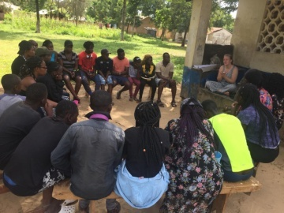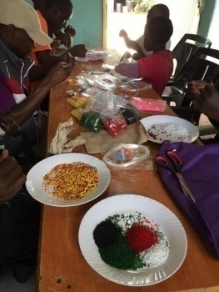SRHR Training in Kilifi: A Real Man Is Project: Youth Beadwork at South C

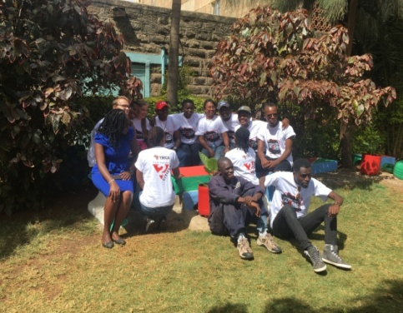
Youth Exchange Programme in Nairobi S2C Training in Mombasa

Specific Objective(s) | Actionable Strategy | Activities
To strengthen the knowledge and skills of over 30,160 youth in Kenya YMCA | Building Youth Self Awareness | -Adopt AAYMCA Career Guidance Manual, Print and distributes 5 copies per branch
 | Building Youth Self Awareness | Train 170 youth TOTS on adopted training manuals on life skills to train youth on self-awareness
 | Building Youth Self Awareness | -Train 4,080 youth on self-awareness within the plan period in all Branches
 | Promotion of civic education/Civic Competence | -Train 1,360 S2C Ambassadors as peace promoters and advocates on issues affecting young people in Kenya within the plan period in all Branches (20 Ambassadors per branch Yearly)
 | Promotion of civic education/Civic Competence | Advocate and Lobby for youth participation both at county and National key decision making organs and youth related funds
 | Promotion of civic education/Civic Competence | -Champion the rights of youth with disabilities in county and national resource allocation
 | Promotion of civic education/Civic Competence | -Join and contribute through networks that champion enactment and implementation of favorable youth policies at County and National
 | Promotion of civic education/Civic Competence | -Sensitize 4,080 youth on Gender Based Violence (GBV)
 | Promotion of civic education/Civic Competence | -Reach out to 1500 youth against participation on violent extremism through inter-faith dialogue
 | Promotion of civic education/Civic Competence | Train 4080 youth on the dangers of drug and substance abuse and SRHR
 | Promotion of civic education/Civic Competence | -Train 510 T.O. Ts Voter educators (30 per branch who will help in Voter Education and Sensitization about governance)
 | Promotion of civic education/Civic Competence | -Sensitize 2,040 Young people on youth opportunities within the Kenya constitution and other legal instrument (60 Youth per year for 4 Years)
 | Promotion of civic education/Civic Competence | -Mobilize students and form 170 Hi Ys clubs @ 20 members  -Train 3400 Hi Y-Club members annually (200 Students per branch per Year x 17 branches)
 | Entrepreneurship Development | -Adopt AAYMCA Entrepreneurship Training Manual, Print and distribute 5 copies per branch
 | Entrepreneurship Development | -Train 170 youth TOTS on adopted training manuals to facilitate Entrepreneurship training programme
 | Entrepreneurship Development | -Conduct business management and financial literacy Training for 2,040 youth  (120 per branch yearly)
 | Entrepreneurship Development | -Organize 68 Business clinic within the plan period at least 1 per Branches annually for 17 branches
 | Entrepreneurship Development | -Facilitate youth enterprises to be supported from government established fund schemes both at county and national level
 | Entrepreneurship Development | -Lobby government to grant tax holiday for youth-initiated enterprises
 | Mentoring and counseling | -Organize at least 3 Group and personal development therapies reaching out to 2550 youth (At least 50 young people per activity per branch
 | Mentoring and counseling | -Conduct Peer Counselors Training @branch training 60 youth annually reaching out to 4,080 youth within the plan period
To Develop the physical and mental status of 1020 young people in Kenya YMCA. | Develop and Promote Youth attractive sports, recreation and activities attracting at least 1020 within Kenya YMCA | -Purchase equipment for indoor Games (Martial arts, Darts, Badminton, Table Tennis, Aerobics, Skating)
 |  | -Facilitate outdoor Games (Foot Ball, basketball, Netball, etc.)
 |  | -Mobilize at least three Theatre, Music and Dance Groups within Kenya YMCA Branches
 |  | -Organize a national sport tournament annually
 |  | -Organize at least 2 Camping activities per branch per year
 |  | -Host World YMCA Challenge day
 |  | -Conduct creative Arts and Cultural competition among Kenya YMCA Branches
 |  | -Acquire adequate materials and equipment for Sporting and Recreation facilities
To provide a platform for linking 3400 young people to opportunities annually. | Link youth to local, national, regional and international opportunities through exchange programs & Job placements and internships opportunities | -Organize exchange programs for 1360 young people
 |  | -Connect 1360 young people to potential employers (20 youths per branch @year for 4 years)
 |  | -Facilitate youth through industrial attachment and internship
 |  | -Organize 68 trade fairs within the plan period at least 1 trade fairs for each branch annually
 |  | -Organize 68 employer’s forum in all 17 branches @year within the plan period
 | Empower youth for economic renaissance | -Organize 272 Career Manenoz at least 4 career manenoz events @ year per branch
 | Empower youth for economic renaissance | -Mobilize youth to form 20 Y-farming clubs in Indangalasia, Chavakali and Limuru  -Train youths on new farming techniques  -Facilitate Y Farming clubs during farm preparation
 | Empower youth for economic renaissance | -Mobilize youth to form 204 VSLAs (Village savings and Loans Association) within the plan period  -Train and Monitor formed groups  -Start saving mobilization programme among youth
 | Empower youth for economic renaissance | -Form and/or link 136 youths income generating projects to existing markets
 | Empower youth for economic renaissance | -Market identification and linkages

EDUCATION AND HUMAN RESOURCE DEVELOPMENT PILAR
- To provide quality and affordable education by training 5000 students within the plan period
- To improve learning facilities & infrastructure by 2023
- To ensure positive and productive work and learning environment by 2023
Kenya YMCA College of Agriculture and Technology (KYCAT)
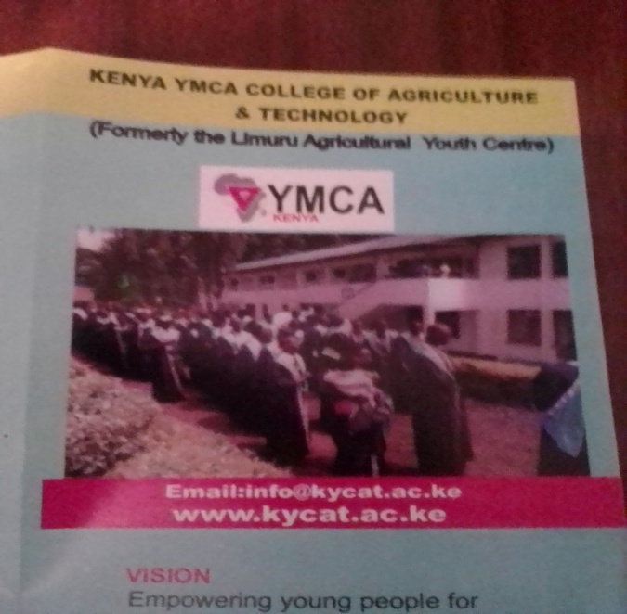
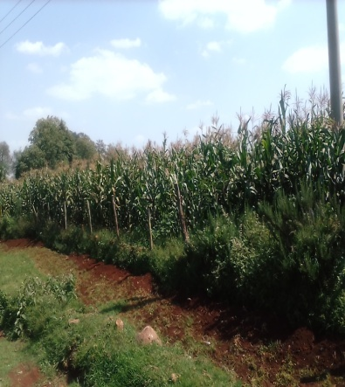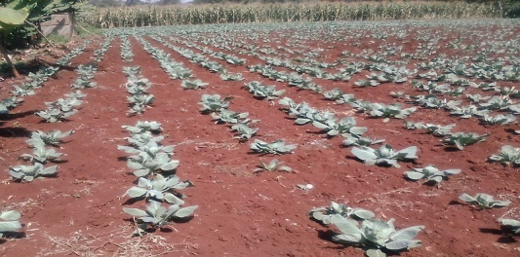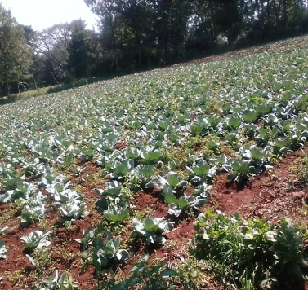
Demonstration Farms
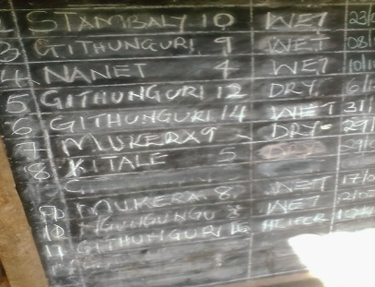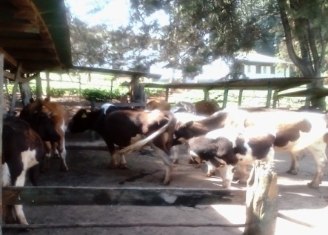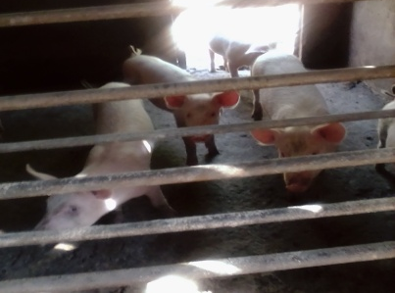
Livestock Demonstration Farms

Kisumu YMCA Vocational Training Centre
Hospitality Training in Progress
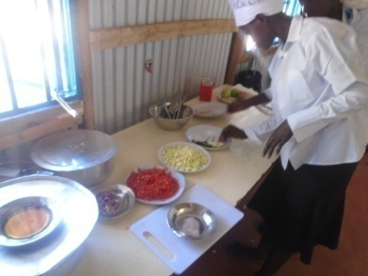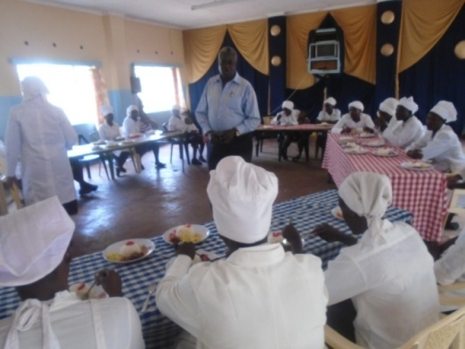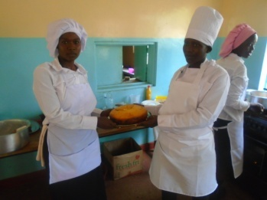
Electrical Students Training on Electricity Board
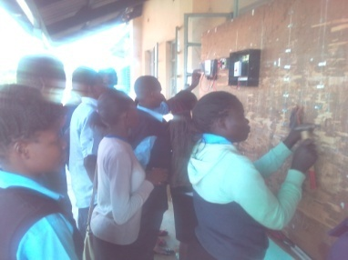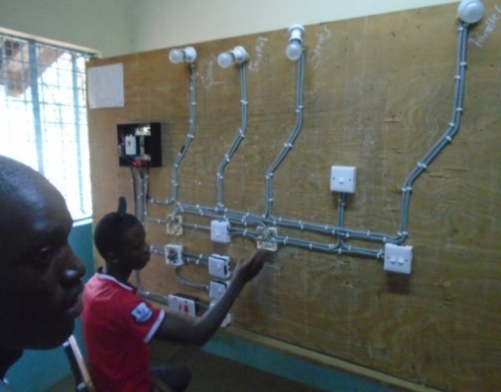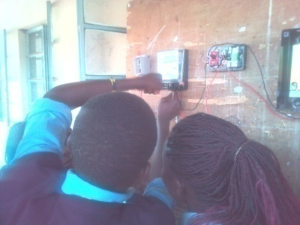

Computer Class in Progress
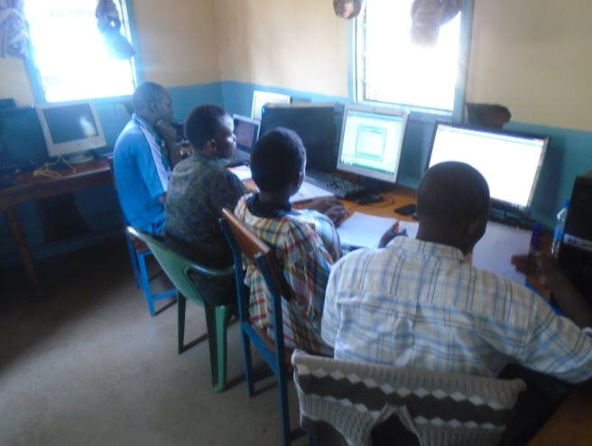

Kenya YMCA National Training Institute
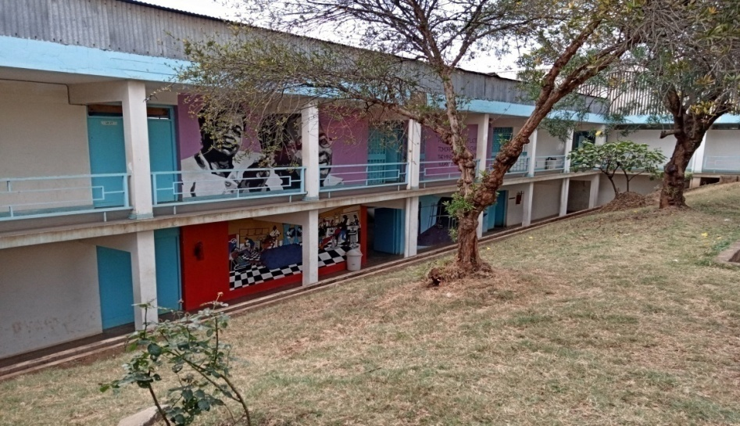
NTI College in Nairobi –Shauri Moyo
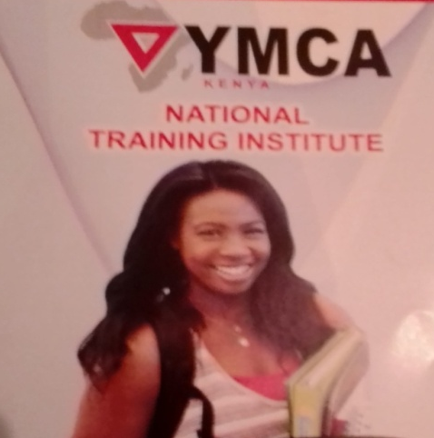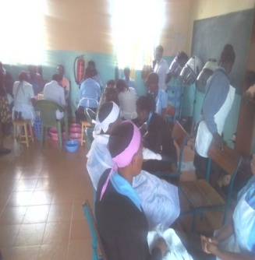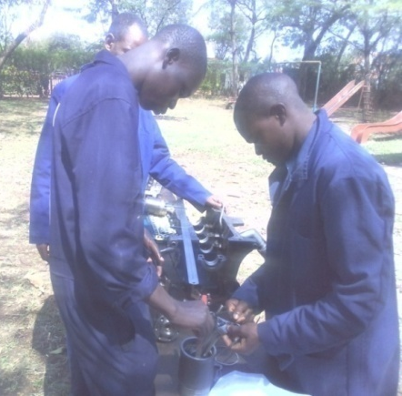
School of Hair Dressing & Beauty Mechanical Student at work

KENYA YMCA Primary & Secondary Schools
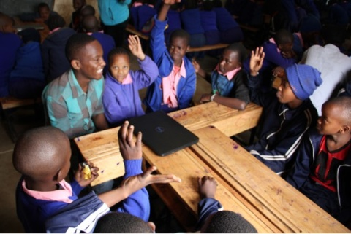
Shauri Moyo Primary School Kenya YMCA Kibera Primary School Kibera Primary School Choir

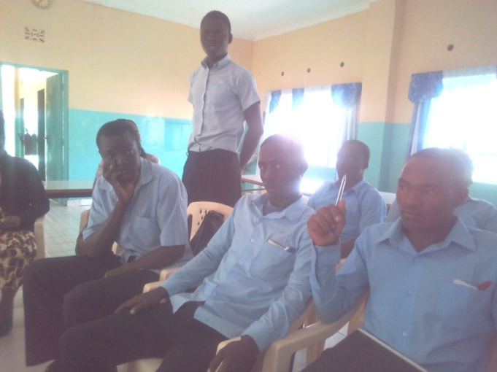

Kenya YMCA Students Dialogue Forum

Specific Objective(s) | Actionable Strategy | Activities
To ensure compliance with set standard as required by the relevant National policies for ECDE, Primary, Secondary and Colleges within Kenya YMCA | Facilitate registration and licensing of 2 ECDE centers by December 2020. | Licensing of Mugona ECDE centers.
 |  | Licensing of Chavakali ECDE centers.
 |  | Register Mugona ECDE centers
 |  | Register KIBERA ECDE school
 |  | Register Chavakali ECDE centers
 | Facilitate renewal, registration, licensing and accreditation of 3 Primary and 1 Secondary Schools by December 2023. | Registration of YMCA Kibera Educational centre and Busia with Ministry of Education.
 |  | Renewal of registration for YMCA Shauri Moyo Primary School and Nakuru Secondary School
 | Facilitate registration, licensing and accreditation of all YMCA Technical Colleges by December 2023. | Acquire accreditation for CDACC, KNEC, and KUCCPS for YMCA NTI
 |  | Acquire accreditation for CDACC, and KUCCPS for YMCA Kisumu
 |  | Acquire accreditation for CDACC and NITA for KYCAT
 |  | Acquire accreditation for CDACC, KASNEB and KUCCPS for YMCA Meru
To enhance recruitment and training of students in all ECDE, Primary, Secondary and Colleges within YMCA Kenya by 2023. | Recruitment and training of 430 students in all YMCA ECDE centers by 2023. | Grow the number of pupils by 35 from the current 20 in year 1 and by 15 for subsequent years for YMCA Mugona Preparatory Centre.
 |  | Grow the number of pupils by 35 from the current 20 in year 1 and by 15 for subsequent years for YMCA Chavakali Preparatory Centre.
 | Recruitment and training of 775 students in all YMCA Primary and Secondary Schools by 2023. | Grow the number of pupils by 15 annually for Kibera YMCA Education Centre.
 |  | Grow the number of students by 20 annually for YMCA Secondary School Nakuru
 |  | Grow the number of pupils by 15 annually for YMCA Shauri Moyo School.
 | Recruitment and training of 2170 students in all YMCA Technical Colleges by 2023. | Grow the number of students by 100 annually for YMCA National Training Institute.
 |  | Grow the number of students by 100 annually for YMCA Kisumu
 |  | Grow the number of students by 100 annually for KYCAT
 |  | Grow the number of students by 100 annually for YMCA Meru
To attract and maintain competent and certified trainers in all YMCA ECDE centers, Primary Schools, Secondary schools and Colleges to the ratio of teacher to student of 1:30 by 2023 | Recruit competent and certified trainers in YMCA Primary School and Secondary Schools to the ratio of teacher to student of 1:30 by 2023. | Conduct extensive marketing for Kenya YMCA schools and colleges
 |  | Recruit and maintain competent and certified teachers at YMCA Kibera Education Centre
 |  | Train 7 teacher in CBC for YMCA Kibera
 |  | Train and maintain competent and certified teachers at YMCA Shauri Moyo Primary School
 |  | Train 5 teacher in CBC for YMCA Shauri Moyo School
 |  | Retain competent and certified teachers at YMCA Nakuru Secondary school
 | Recruit competent and certified trainers in all Kenya YMCA Colleges to the ratio of teacher to student of 1:25 by 2023 | Train and ensure certification of teachers at YMCA NTI (CDACC, TVETA, NITA)
 |  | Train and ensure certification of teachers at YMCA Kisumu (CDACC, TVETA, NITA,)
 |  | Train and ensure certification of teachers at KYCAT (CDACC, TVETA, NITA, KVB)
 |  | Train and ensure certification of teachers at YMCA Meru (KASNEB)
 | Develop supportive alumni in all YMCA Colleges and Secondary schools at 40% of every final class by 2023. | Form alumni platform for Kenya YMCA Nakuru Secondary school
 |  | Form alumni platform for Kenya YMCA Kisumu
 |  | Form alumni platform for KYCAT
 |  | Form alumni platform alumni for YMCA NTI
 |  | Form alumni platform for YMCA Meru
 | Acquire approved curricula in all YMCA Colleges by2023. | Implement TVETA approved curricula in YMCA NTI
 | Acquire approved curricula in all YMCA Colleges by2023. | Implement TVETA approved curricula in KYCAT
 | Acquire approved curricula in all YMCA Colleges by2023. | Implement TVETA approved curricula in YMCA Kisumu
To enhance performance of all YMCA ECDE, Primary schools and Secondary schools and Colleges by 2023. | Ensure improved performance, transition and completion rates for all YMCA ECDE, Primary and Secondary schools and Colleges by 2023. | Teach and transit 100% of the students to the next level annually in all Kenya YMCA ECDE Institution.
-Teach and transit 100% of the students to the next level annually in all Kenya YMCA primary and secondary schools
-Achieve a mean score of 350 for all YMCA primary schools at the end of std 8 by 2023
 |  | Achieve a mean score of 5.5 for all Kenya YMCA secondary schools by 2023
 |  | Achieve 95% completion rate of competent graduates at YMCA NTI
 |  | Achieve 95% completion rate of competent graduates at KYCAT
 |  | Achieve 95% completion rate of competent graduates at YMCA Kisumu
 |  | Achieve 95% completion rate of competent graduates at YMCA Meru
To provide adequate learning tools, equipment and facilities for all YMCA ECDE, Primary schools, Secondary schools and Colleges by 2023 | Ensure adequate learning tools and equipment for all YMCA ECDE, Primary schools, Secondary schools and Colleges by 2023 | Acquire learning tools and equipment for YMCA Chavakali ECDE Centre.
 |  | Acquire learning tools and equipment for YMCA Mugona ECDE Centre.
 |  | Acquire learning tools and equipment for Kibera Education Centre.
 |  | Acquire learning tools and equipment for YMCA Shauri Moyo ECDE
 |  | Acquire learning tools and equipment for Busia Primary School
 |  | Acquire learning tools and equipment for YMCA Nakuru Secondary School.
 |  | Acquire learning tools and equipment for YMCA NTI
 |  | Acquire learning tools and equipment for KYCAT Limuru
 |  | Acquire learning tools and equipment for YMCA Kisumu
 |  | Acquire learning tools and equipment for YMCA Meru.
 | Improved facilities and infrastructure that promote learning to all YMCA ECDE, Primary schools, Secondary schools and Colleges by 2023. | Renovate class rooms in YMCA Chavakali ECDE Centre.
 |  | Renovate class rooms in YMCA Mugona ECDE Centre.
 |  | Renovate 8 class rooms and 1 staff room in YMCA Kibera Primary school.
 |  | Renovate 6 class rooms and construct 1ablution block in YMCA Shauri Moyo primary school
 |  | Renovate 6 class rooms and laboratory YMCA Nakuru Secondary school.
 |  | Renovate 6 class rooms and construct new facilities at YMCA NTI.
 |  | Renovation, construction, furnishing and Purchase of livestock and college Bus at KYCAT
 |  | Renovate 6class rooms and construction of new facilities at YMCA Kisumu.
 |  | Renovate 6 class rooms and construction of new facilities at YMCA Meru.
To ensure all YMCA ECDE centers, Primary schools, Secondary and Colleges have relevant work place policies by 2023. | Institute work place policies in all YMCA ECDE centers, Primary schools, Secondary schools and Colleges by 2023 | Develop work place policies for YMCA ECDE Centres, Primary and Secondary schools.  -Teachers code of conduct  -Students rules and regulation  -Health and Safety Policies  -Sexual Harassment
Develop work place policies for YMCA Colleges
-Examination Policies
-Attachment policies
-Gender Policies
-Code of conduct for Teachers
-Sexual Harassment policies
-Health and safety
-Students Handbook
To enhance the management of all learning institution within Kenya YMCA .by 2023. | Stream line management structures of all ECDE, Primary, Secondary schools and colleges within Kenya YMCA in accordance with Ministry of Education and TVETA requirements. | Establish BOM in Mugona ECDE Centre, Kibera, Chavakali, Shauri Moyo and activate Nakuru BOM
 | Establish Board of Management in all colleges according to the Ministry of Education and TVET Act requirements by 2023. | Reconstitute and train BOM for NTI, KYCAT and Kisumu.

INSTITUTIONAL STRENGTHENING PILLAR
- To expand and strengthen all Kenya YMCA resource capabilities
- To strengthen Human Resources functions within Kenya YMCA
- To enhance learning and knowledge management
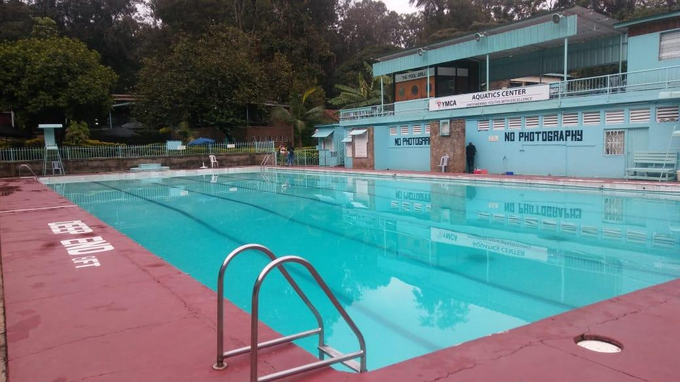
Kenya YMCA Swimming pool at Central Branch-Nairobi
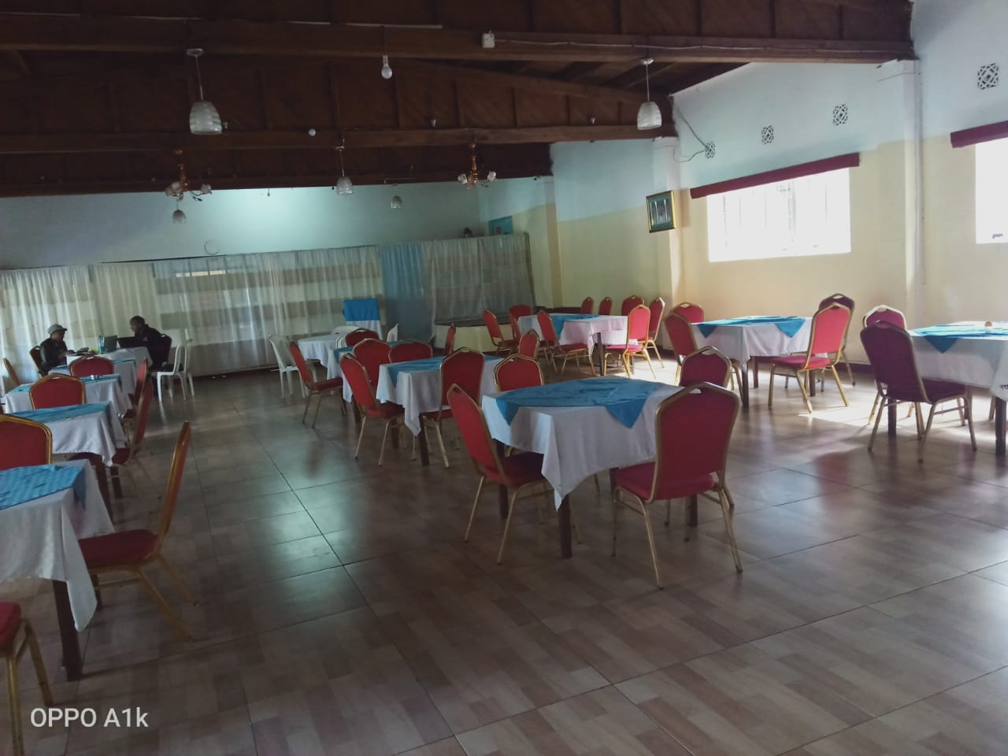

Specific Objective(s) | Actionable Strategy | Activities
To expand and strengthen all Kenya YMCA resource capabilities | Secure Kenya YMCA Properties/Assets | Acquire title deeds to secure all Kenya YMCA Properties
 | Secure Kenya YMCA Properties/Assets | Reclaim all land and any other property for Kenya YMCA such as Kilifi and Nyeri Land that may be lost through fraudulent cases
 | Enhance revenue base by 10% annually | -Conduct Marketing & Branding of the Association services in order to attract more customers (Hospitality, schools and colleges)
 | Enhance revenue base by 10% annually | Diversify Association services by:  -Introducing outside catering and camping services (Naivasha, Kisumu, Central, South C and Shauri Moyo)
 | Enhance revenue base by 10% annually | -Introduce theme menu (African Dishes) in the eatery centres
 | Enhance revenue base by 10% annually | -Introduce MPESA services in major cost centers in Central, Meru, South C, Kisumu, Shauri moyo and Limuru.
 | Enhance revenue base by 10% annually | -Start commercial farming activities for branches in Limuru, Chavakali, Indangalasia, Thika, Githumu, Mugona and Nyeri,
 | Enhance revenue base by 10% annually | -Improve on Livestock farming in Limuru Branch,
 | Enhance revenue base by 10% annually | -Develop Children’s park in branches in Central, South C, Naivasha, and Shauri Moyo).
 | Resource Mobilization | -Map out and identify key strategic partners and needs:  - Asset Development needs  - Programme Expansion needs  - Establish partners Directory  - Proposal writing needs  - Local fundraising needs
 | Resource Mobilization | Train staff (managers, programme coordinators and board members) on resource mobilization skills,  -Network building Skills  -Proposal writing Skills  -Fundraising Skills
 | Resource Mobilization | -Carry out resource mobilization campaign targeting local banks for cheap loans, international and local partners, donors, volunteers, members and sale of certain properties for re-investment in prime locations
 | Renovation and modernization of existing facilities | -Renovate Shauri Moyo Hostel
 | Renovation and modernization of existing facilities | -Undertake repair of. South C Hostel
 | Renovation and modernization of existing facilities | -Undertake repair of central hostel
 | Renovation and modernization of existing facilities | -Undertake repair of Naivasha camp
 | Renovation and modernization of existing facilities | -Undertake repair of Chavakali hall
 | Renovation and modernization of existing facilities | -Undertake repair of Indangalasia offices and Rental houses
 | Renovation and modernization of existing facilities | -Undertake repair of Kilifi offices
 | Renovation and modernization of existing facilities | -Undertake repair of Mombasa hostel
 | Cost reduction by 20% | Install Solar Panels in Kenya YMCA centers to save on electricity cost
 | Cost reduction by 20% | Review financial, and Procurement policy Manuals
 | Cost reduction by 20% | Train staff on financial regulation and Procurement policies
 | Cost reduction by 20% | Develop and train staff on security policy
 | Cost reduction by 20% | Enforce strict adherence to budget and budgetary control
 | Cost reduction by 20% | Put in place effective debt recovery system
 | Cost reduction by 20% | Conduct both internal and External Audit Regularly
To enhance learning and knowledge management within Kenya YMCA | Improve on documentation and sharing | Establish Information Management System in all departments/Branches
 | Improve on documentation and sharing | Undertake effective data collection through M&E within organization
 | Improve on documentation and sharing | Organize more sharing forums
 | Research & Publication | -Conduct baseline surveys and post plan and programme evaluation on the organization needs from different branches  -Initiate organization quarterly Newsletter & -E-Newsletter
 | Monitoring, Evaluation, Report &Learning | Develop a tool for M, E, R, & L for YMCA Programmes
 | Monitoring, Evaluation, Report &Learning | Review of monitoring policies
To Strengthen Human Resources functions within Kenya YMCA | Attract, develop and retain adequate skilled, committed and competent staff | Set up position of Education Coordinator at the Head Office to oversee overall operation of all Kenya YMCA learning institution.
To Strengthen Human Resources functions within Kenya YMCA |  | Set up position of Resource Mobilization Officer at HQs to assist branches in resource mobilization.
To Strengthen Human Resources functions within Kenya YMCA |  | -Undertake staff audit in all the branches to establish capacity needs  -Recruitment to strategic positions & Orientation
To Strengthen Human Resources functions within Kenya YMCA |  | -Undertake salary and remuneration survey & -Implement competitive & attractive salary and remuneration scheme
To Strengthen Human Resources functions within Kenya YMCA | Build capacity of staff to effectively undertake organization activities | -Review HR Manual to include succession planning and management policies within the organization on staff exit
To Strengthen Human Resources functions within Kenya YMCA |  | Conduct regular job training for staff serving in critical areas
To Strengthen Human Resources functions within Kenya YMCA |  | Identify relevant organizations to Partner with in building capacity of staff
To Strengthen Human Resources functions within Kenya YMCA | Strengthen Performance management system | Facilitate learning from best practices through Benchmarking & Peer review
To Strengthen Human Resources functions within Kenya YMCA | Strengthen Performance management system | Organize Job rotation for staff in cost centres for Knowledge, experience and learning
To Strengthen Human Resources functions within Kenya YMCA | Strengthen Performance management system | Equip staff with the right tools
To Strengthen Human Resources functions within Kenya YMCA | Strengthen Performance management system | Review performance management system
To Strengthen Human Resources functions within Kenya YMCA | Strengthen Performance management system | Review of organization structure
To Strengthen Human Resources functions within Kenya YMCA | Strengthen Performance management system | Undertake extensive capacity building on PMS
To Strengthen Human Resources functions within Kenya YMCA | Strengthen Performance management system | Coordinate and Communicate to all staff the HR and Sexual Harassment policies
 | Motivation | Provide a conducive environment for staff performance
 | Motivation | Reward good performance

Estimates for Kenya YMCA Strategic Plan 2020-2023
Pillar | Objectives | Amount  KES
Membership, Leadership and Spiritual Development | To expand and strengthen Kenya YMCA membership base by 26,300 members within the plan period | 16,240,000.00
Membership, Leadership and Spiritual Development | To enhance the leadership capacities of 2,630 the members of Kenya YMCA | 9,760,000.00
Membership, Leadership and Spiritual Development | To strengthen Christian Emphasis at all levels of the Kenya YMCA | 2,600,000.00
Total | Membership, Leadership and Spiritual Development | 28,600,000.00
 | To strengthen the knowledge and skills of 30,600 youth in Kenya YMCA | 38,402,000.00
Youth Empowerment | To develop the physical and mental status of 1,020 young people in Kenya YMCA | 6,000,000.00
 | To provide a platform for linking at least 3400 young people to opportunities annually | 21,960,000.00
Total | Youth Empowerment | 66,362,000.00
Education and Human Resource Development | To Provide Quality and affordable Education by Training 5000 students within the plan period | 6,435,000.00
Education and Human Resource Development | To Enhance Learning Facilities & Infrastructure by 2023 | 226,180,000.00
Education and Human Resource Development | To Ensure positive and productive work and learning environment by 2023 | 800,000.00
Total | Education and Human Resource Development | 233,415,000.00
Institutional Strengthening | To expand and strengthen all Kenya YMCA resource capabilities | 322,300,000.00
Institutional Strengthening | Strengthen Human Resources functions within Kenya YMCA | 6,150,000.00
Institutional Strengthening | To enhance learning and knowledge management | 2,000,000.00
Total | Institutional Strengthening | 605,450,000.00
GRAND TOTAL |  | 933,827,000.00

Kenya YMCA National Secretariat
State House Road, Nairobi, Next to United Kenya Club
P.O Box 30330-00100 Nairobi, Kenya
Tel: +254-2713599/2724116/7, 2724066/70
Direct Line +2540729152816/0736330715
Email; info@ymcakenya.org
Web: www.kenyaymca.org

